Preface
From a distance of four decades, re-editing this account with photos, a number of aspects jump out at me.
Firstly, the great inspiration given me and others by the example of Ralph Sherwin, Edmund Campion and their contemporaries, brave missionaries to a hostile homeland.
Next, my openness to providence, the unknown possibilities that travel presents (from distance of over 35 years),
Third, the welcome and hospitality for the travelling stranger.
And finally, a glimpse at Europe and England’s part in it in the autumn of 1987.
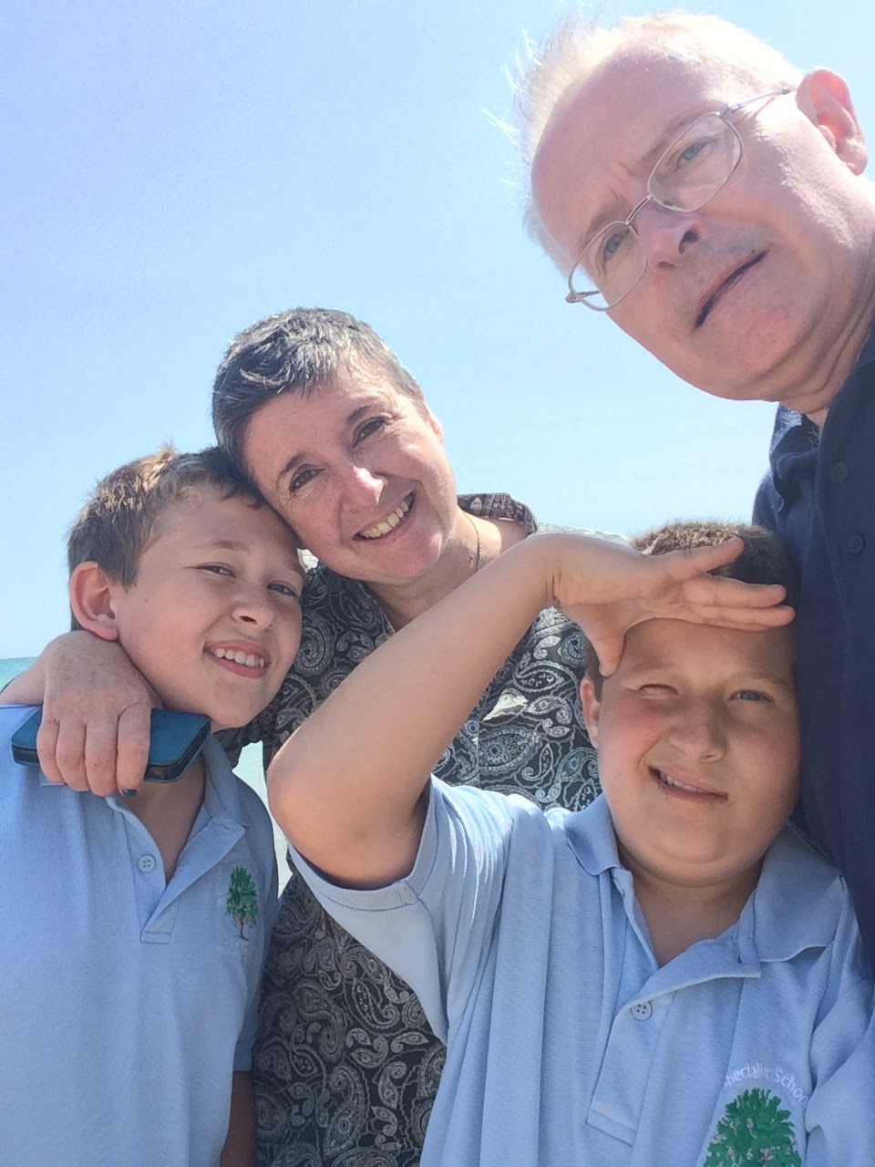

Presented to you in the midst of my present odyssey, with my wife Jane and our sons Luke and Ben, photo 5 years back.

A TALE OF THREE JOURNEYS
In order to appreciate this account of my autumn 1987 Rome to London odyssey, two earlier journeys need to be taken into account.
The First Journey
The first and foremost ‘Ralphroute’ was that made by St Edmund Campion, St Ralph Sherwin, and their party of English bishops, priests and laymen from Rome to Rheims and onwards to England in 1580, as a spiritual Mission to England.
The route which that party took could only lead to persecution, imprisonment or death, as is well-documented elsewhere. That was the tragic finishing point for them and for many other 16th century priests from my college in Rome, the English College. Due to its 44 graduate martyrs it was given the title ‘Venerable’ by the Vatican.
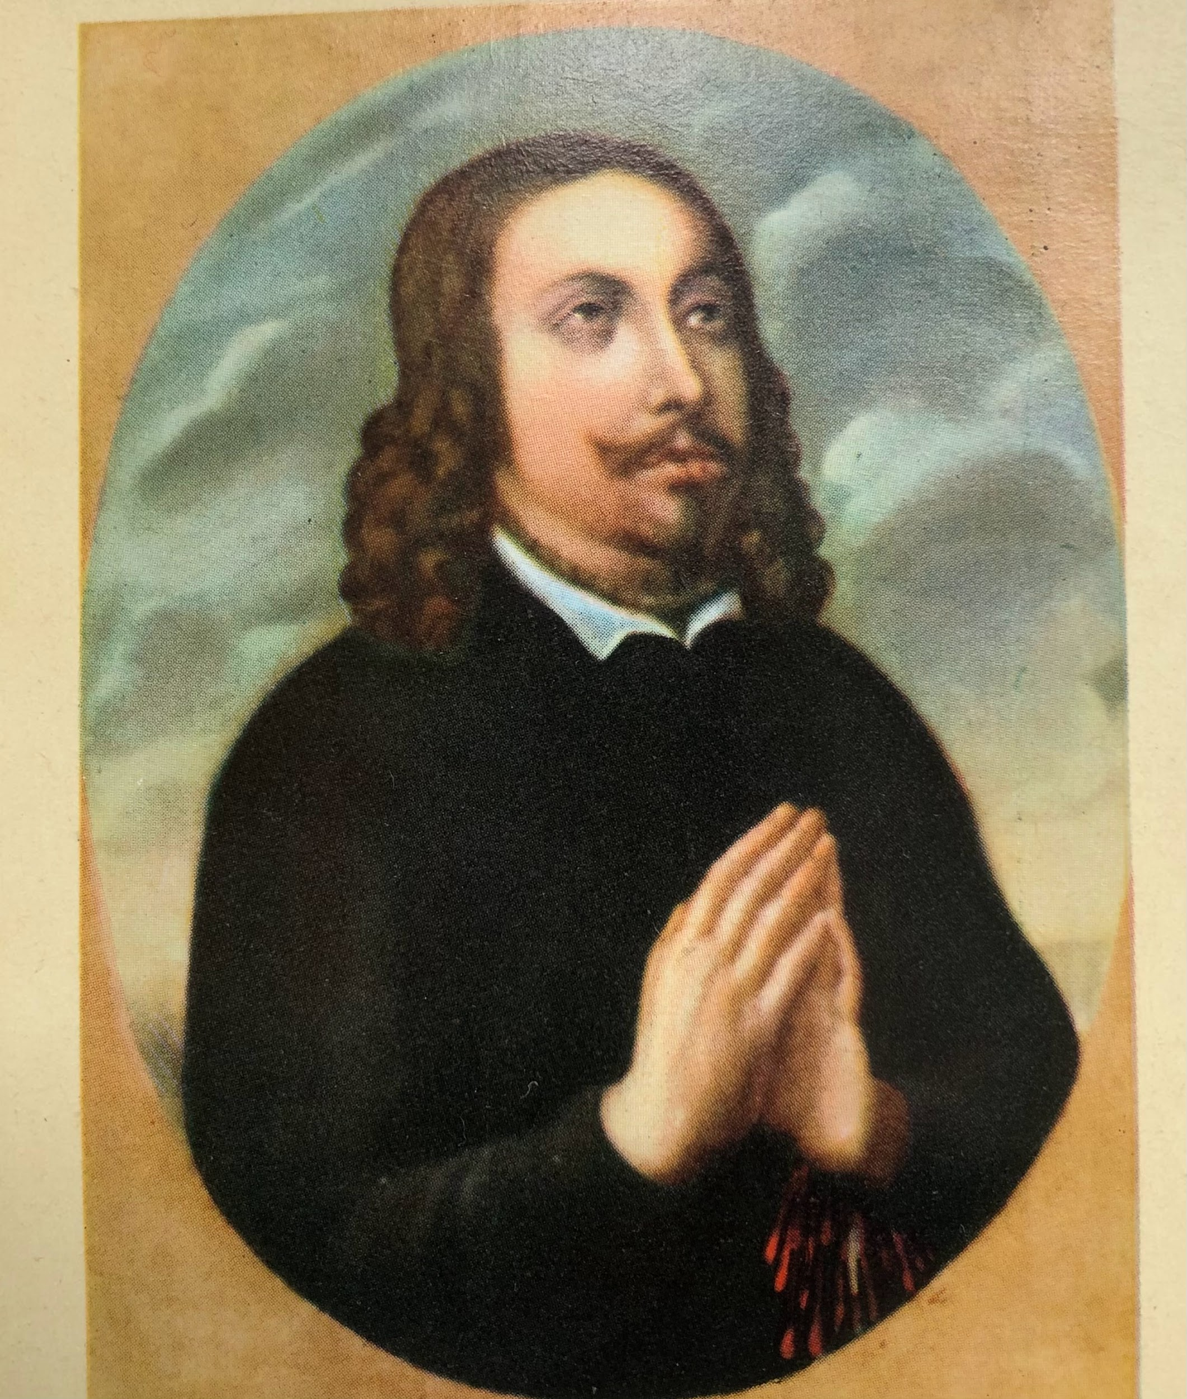
Above, the first martyr of the English College Rome, St Ralph Sherwin.
Below is The Martyrs Picture, located in the English College Chapel. Each time news came back to Rome about the execution of another ex-student for his Catholic faith, the college community gathered to sing the ancient ‘Te Deum’ hymn to God. It includes the lines: “In you, Lord, have hoped, may I not have hoped in vain” (my translation).
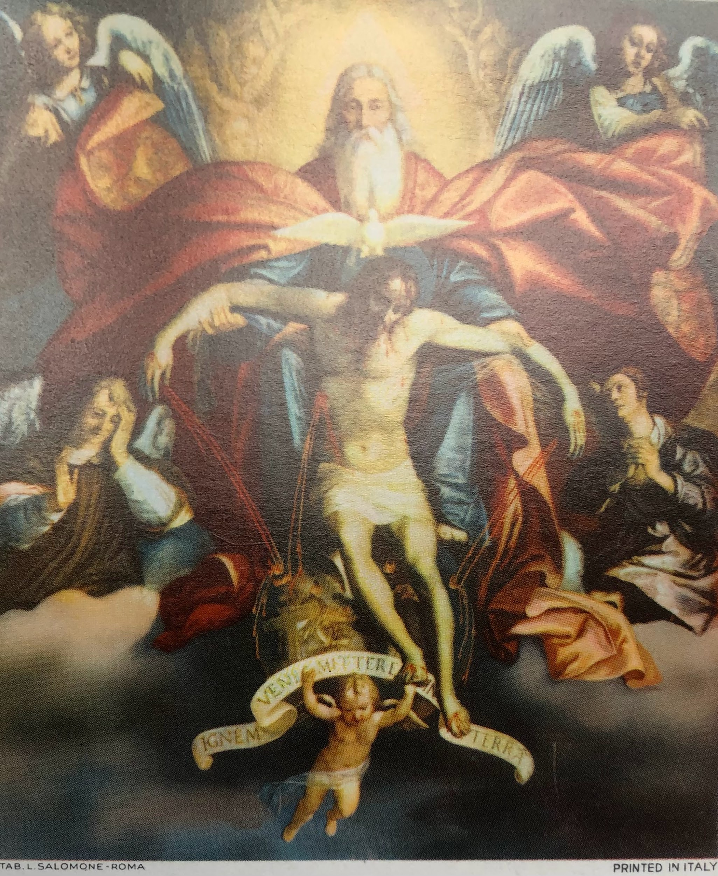
The Second Journey
To remember the dedication and generosity of those 1580 travellers, and of the God who gave them those qualities, a second journey for July 1987 was planned by a latter-day group of newly-minted priests from the English College, who had been studying since 1980 and 1981. It was a journey which aimed to imitate the key points of the route taken by the martyrs of old. As such, it was very successful, making stops at Milan, Geneva and Rheims. It added an additional overnight stay at Douai, the original English seminary-in-exile and the mother of all the seminaries training priests to serve in England.
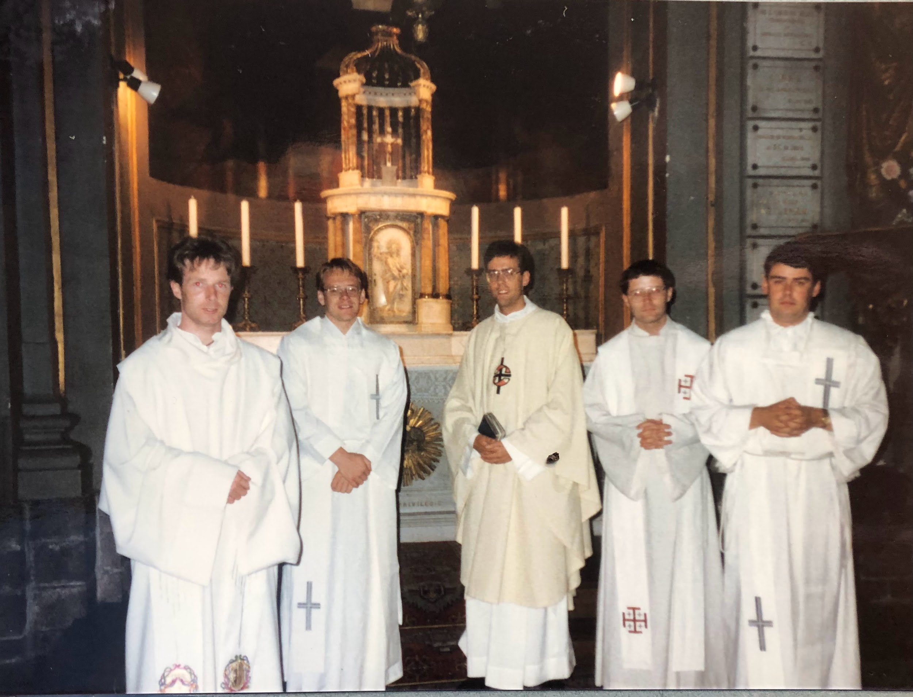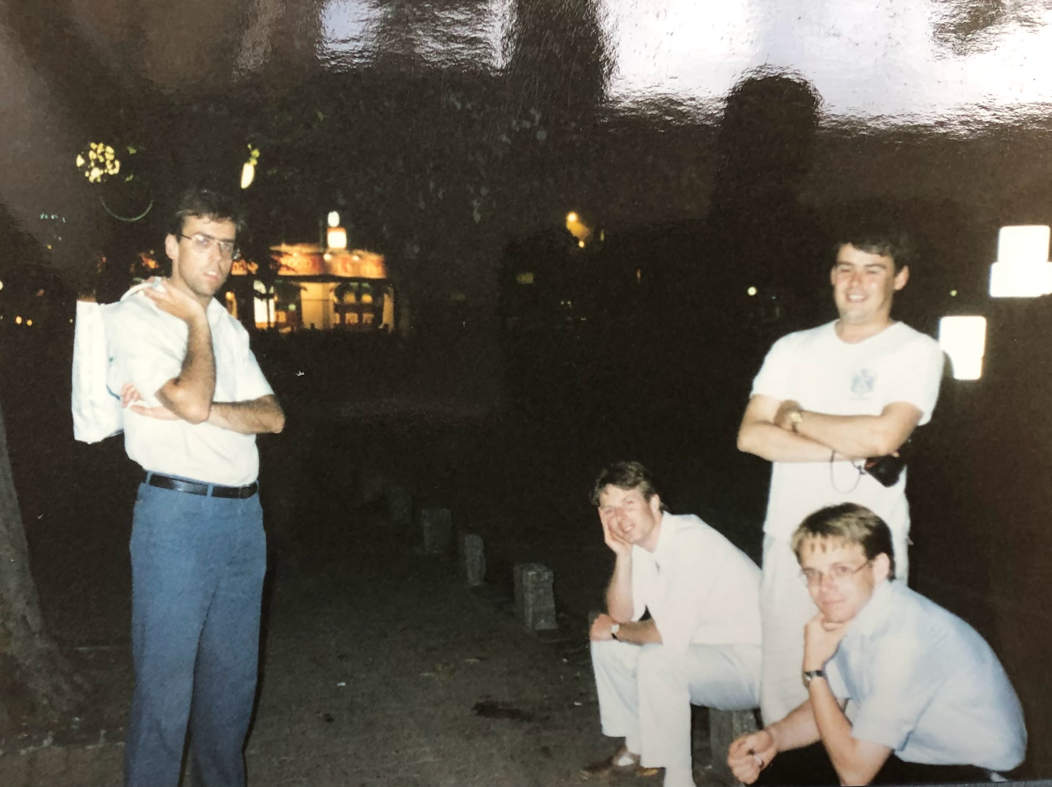
The photos show moments in this journey made by Michael Raiswell, Charles Briggs and Anthony Towey (all three now sadly deceased) along with Raglan Hay-Will, Nicholas Hudson and myself, the final generation of students to leave the college as priests. From then on student seminarians were to be ordained priests only after their studies were over and they had returned to England.
The Third Journey - In you, Lord, is my hope.
Having given this background, the account which now follows records neither of these two journeys, but my own first journey home from after completing my studies at San Anselmo in the late autumn of 1987. Didn’t I go home with the guys above? Well yes, but unlike them I had to return to finish a dissertation and take my finals, so I got to have a second run at it, aiming for a route which more exactly (but not completely) mirrored the 1580 journey.
My autumn journey, which brought to an end my seven years of ‘Romayne life’ had the advantage of more time to linger than July’s trip. I affectionately called this pilgrimage ‘The Ralphroute’ in memory of St Ralph Sherwin mentioned above.
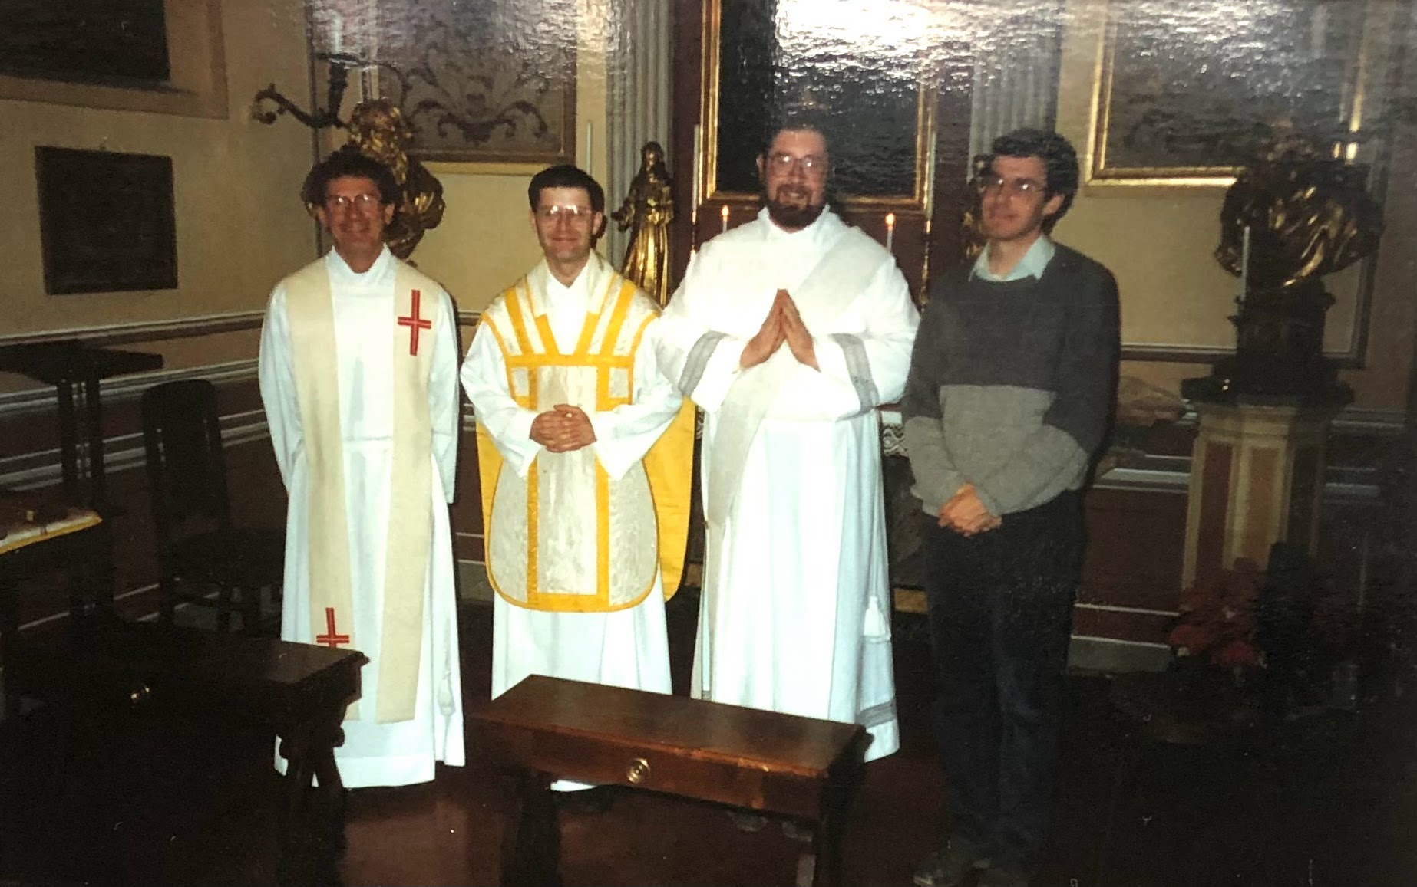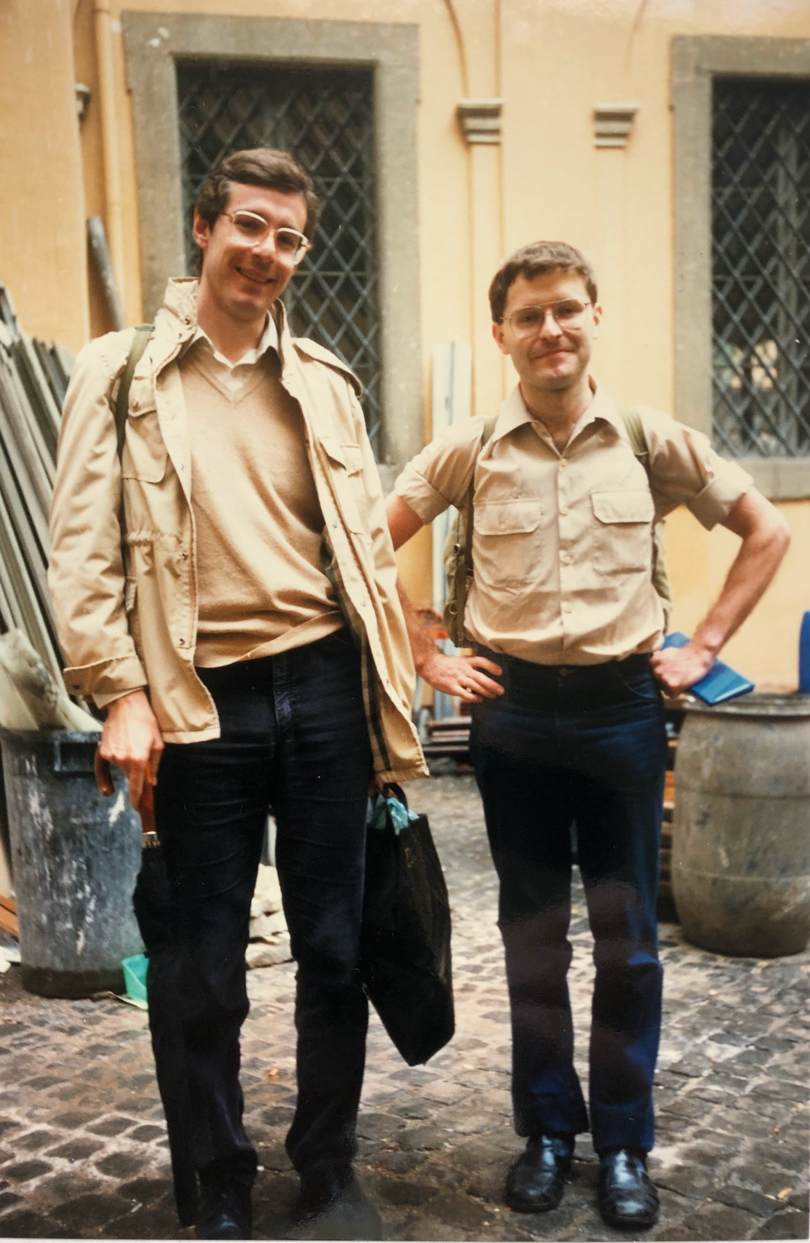

Thursday, 29 October, Rome to Viterbo. By foot and bus, day 1.
The end of the road, the beginning of the route. I had said a prayerful goodbye presiding at the Community Mass the night before, so my morning farewell was in the English College kitchen, saying goodbye to the Elisabettine sisters and kitchen staff who had cooked my (amazing) meals and done my laundry for the last seven years, who presented me a packed lunch for day 1 of the trek. All that remained now was to complete my entry in the College record book, the ancient Liber Ruber, to say goodbye, and to take to the road. In a moment of inspiration, putting my own spin on venerable tradition, I signed the ancient tome not with the customary "Ita est" (It is Done) but with "Ita est est est!", the name of a local wine.
I embraced the kind students and friends who had gathered to see me off and departed via the courtyard at 9.05am. Up to the end of our road, the Via Monserrato, Alison and Olivia Macdonald kept me company, young Australians from a flat next door to the College. Then, as we were saying our goodbyes, their dad Angus pulled up in his car and jokingly offered a lift across town to myself and Liverpool seminarian Michael O'Connor, my companion for the day. As Angus suspected, I was keen to leave Rome on shanks pony, on foot. A kind thought all the same. Farewell you neighbours of Monserrato and Piazza Farnese!
Michael and myself made our way up to St Peter's in the lightest of drizzle, down the Lungotevere and through the Borgo Santo Spirito gateway, past the Jesuit buildings and on up the Via Conciliazione. We popped into St Peter's for a moment or two, prayed for a safe journey and fruitful future, glanced at Michaelangelo's Pieta, and left the Vatican on the Sant'Anna side of the colonnade, walking in heavy rain up by the connecting passage to Castel Sant' Angelo over the bridge of that name and up the Lungotevere to the Ponte Milvio. To be one hundred percent authentic, as I later realised, we should have left by the Piazza del Popolo, but I reckon that Ralph and the boys would have walked up the Lungotevere under the shade of the trees if there had been a flood as they departed (and if there had been a Lungotevere to walk on).
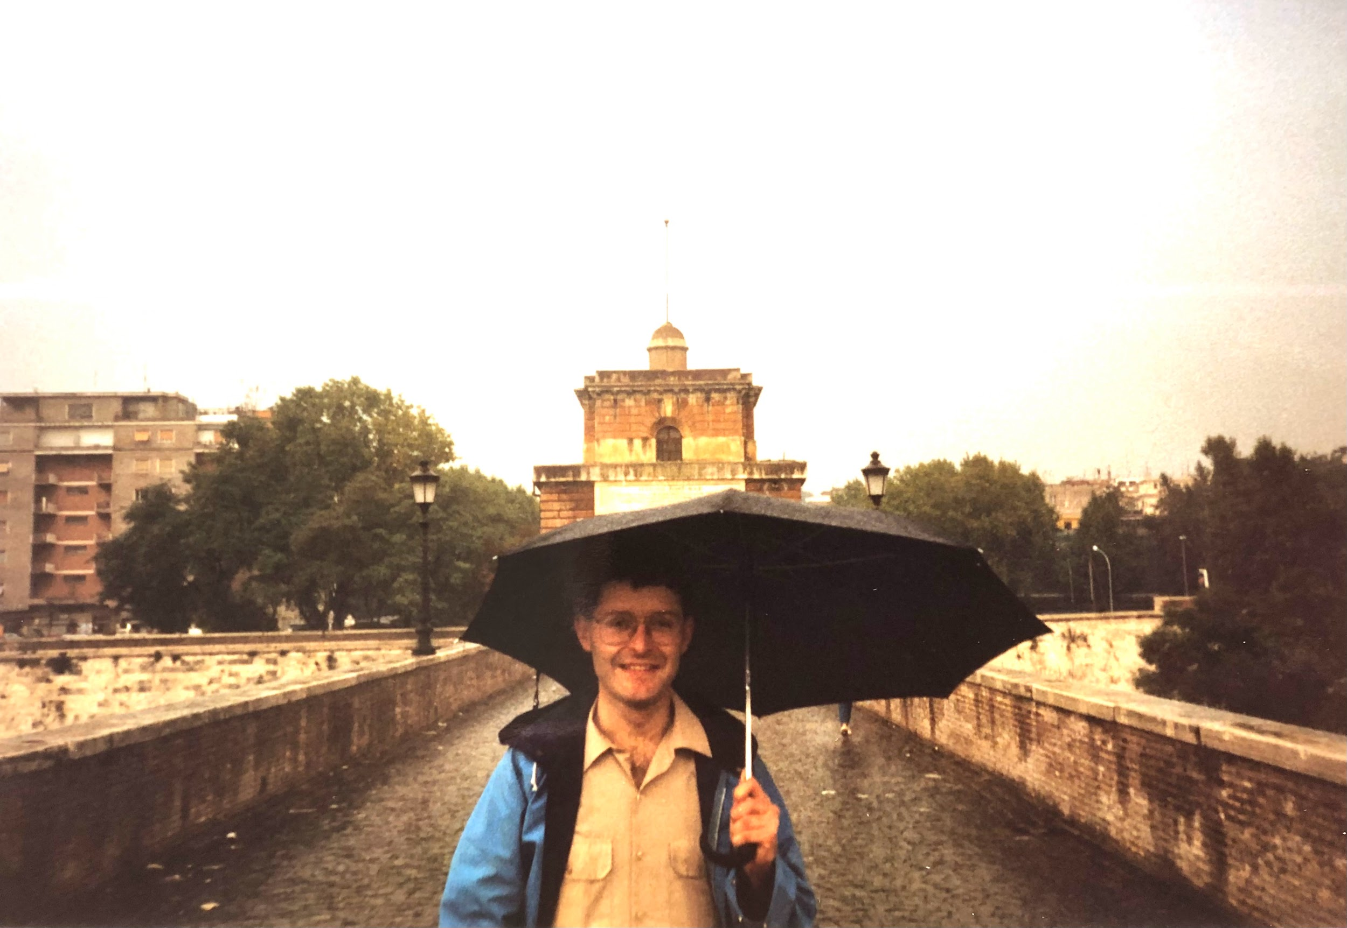
So, we crossed the Ponte Milvio, stopping for a photo or two, had a coffee, bought bus tickets and just about managed to get the bus driver to stop and pick us up. It rained all the way to Viterbo, the progress of the bus being occasionally broken by flooded roads. We reached monsoon-ridden Viterbo at about 1.30pm. We had lunch at 'L Richiastro, on the Via della Marrocca, feasting on three different types of soup, lentil, mushroom and cabbage! Apparently, it was all very Etruscan. Spiedini and sausage followed. "That meal was brought to you c/o Mike O'C and Sue MacD. Finances Inc." Very nice too, especially as my funds are a little dodgy at the moment. Leaving college cost me more than living in it!
After lunch I looked for a bed at the regional seminary on Via IV Novembre, but they were no longer able to take overnight guests so they advised me to try the Capuchins. The doorman lay-brother was a friendly ‘late vocation’ who used to be sacristan at Maria degli Angeli, on the Piazza Repubblica back in Roma. The monk-in-charge looked much more harried. Come back at 6.30pm he said, so I changed into dry socks and out of my sandals, left my bags there, and went back out into the rain. Mike and I did the traditional thing English College students do on their (universities closed) Thursdays: Go on a gita, get a bus or train to a town and its Duomo (Cathedral) and ‘centro storico’, the historic centre. We had already completed part 1 after all, the spaghetti and the cappuccino. Now for part 2. Viterbo has gone down in history as its Papal Palace was unroofed by the local people in a mid-summer effort to bring an end to a papal conclave which had become paralysed in making its choice for the next Pope. The church of San Sisto was notable too, a veritable stairway to heaven. We wandered the piazzas and alleyways and reminisced about other roman holidays of days gone by, stopping only to drink a final coffee and Campari and soda until it was time for Mike’s train back to Rome. When I finally saw him depart it felt like the umbilical cord with the College was cut at last! I wasn't that sad but I thought (again) of Dionne Warwick's "Every time you say goodbye, I die a little".

A different lyric came to mind a minute later when the ticket-seller could give me only a blank look when I asked him the best route from Viterbo to Siena: "It means nothing to me - ah! Siena!" (Ultravox amended). A garbled version of St Ralph Sherwin's saying also came to mind: "Pontius sparrowum quam snailem" (I'd rather be a sparrow than a snail, but either transport is better than Rome-London by plane).

Anyway.... I was exhausted. I slept only 3.20am - 6.00am last night after a meal out, a goodbye to friends, packing, and a million loose ends. Weary, I returned to the Capuccs, waiting in the lobby chatting to the doorman and reading my breviary. Brother Roberto arrived and whisked me off to supper in a very modern refectory. I ate very little, sitting surrounded by eccentric but hospitable monks. One of them was an Italo-American who had plans to study at San Anselmo College in Rome. He showed me to my room, helped me with my bags, made my bed, warned me about the loos, and alerted me to the bells in would hear next morning. He need not have worried, I slept through the 6.00am classical music tannoy !

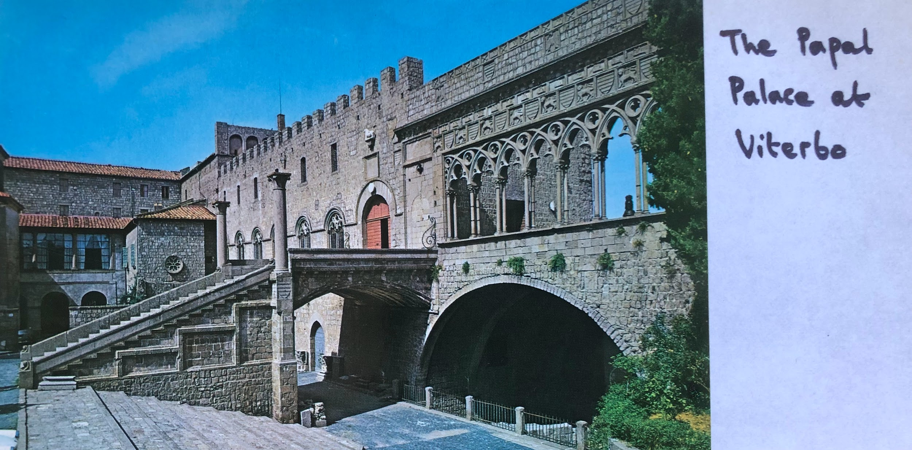

Friday, 30 October - Viterbo to Siena. By foot, bus and hitchhiking. Day 2.
I dropped off to sleep at 9.45pm and woke up at 8.00am, interrupted only momentarily when the bells calling the monks to prayer sounded off. I prayed, shaved, and said goodbye to the monk-in-charge, who offered me coffee. I took it and offered the house some cash for its hospitality. He carried on reading his newspaper and told me not to worry about it. Meanwhile, Brother Roberto had wangled permission to cut class and take me to the bus station. Much appreciated. "Oremus pro invicem?", he said as we parted. "Absolutely!", I replied, we’ll pray for each other. I was going to need spiritual support over the days ahead. I wrote postcards whilst waiting for a bus north to (interestingly-named) Acquapendente, hanging water. Made my mind wonder to Acqua Dependente, home of poor creatures addicted to water. Who should then appear and bring me back to earth but Fr Carlo Huber, a philosophy prof who had taught me (a little) at the Gregorian University. My past as his wary student rushed before me but I soon regained consciousness and wished him a happy day, with his accompanying scout group. The rain was clearing and the clouds were breaking up. Grey to begin, but brightening.

Got off the bus at Acqua Dependantsville. No sign of water-sniffing on the street, I'm happy to say. As the bus went no further than this point in the direction of Siena, I began hitch-hiking, which was going to be an essential part of my travel. After a while standing beside the petrol station on the road out of town, a young factory worker called Livinio, with a knee problem and Simple Minds on his tape player, stopped to give me a lift. He chatted away about how much he didn't like Viterbo. It had three too many military barracks for his liking, he spoke from experience as he had served his time as a conscript in one of them. He didn't think that folks were sincere about friendship in Viterbo. He travels a great deal and wants to come to England someday. I hope he has better luck there.

Well, Livinio dropped me 18 kms down the road - about 75 kms from my target Siena. As I stood at the side of the road the weather became sunnier. I contemplated walking to Siena. An attack of sanity turned me against that option. As I waited for a lift I passed time by composing alternative addresses and appellations for the Venerable English College: the Vulnerable Eyewash Collage, the Veritable Egghead Carriage, the Very Angst Courage, and so on...

Interrupting this reverie, I was grateful to be picked up by two Dutch tourists called Stephen and Raneer who were heading home after a holiday in a nearby village. Conversation was pretty piecemeal, even though I was overflowing with appreciation at their offer to drop me just outside Siena. Perhaps they were put off by the fact that I was a priest, perhaps it was only a language problem. Anyway, I dozed off and when I woke up the car was stopping at the carpark at the foot of the hilltown called Siena. First came a farewell of great gratitude, then a long and weary climb.

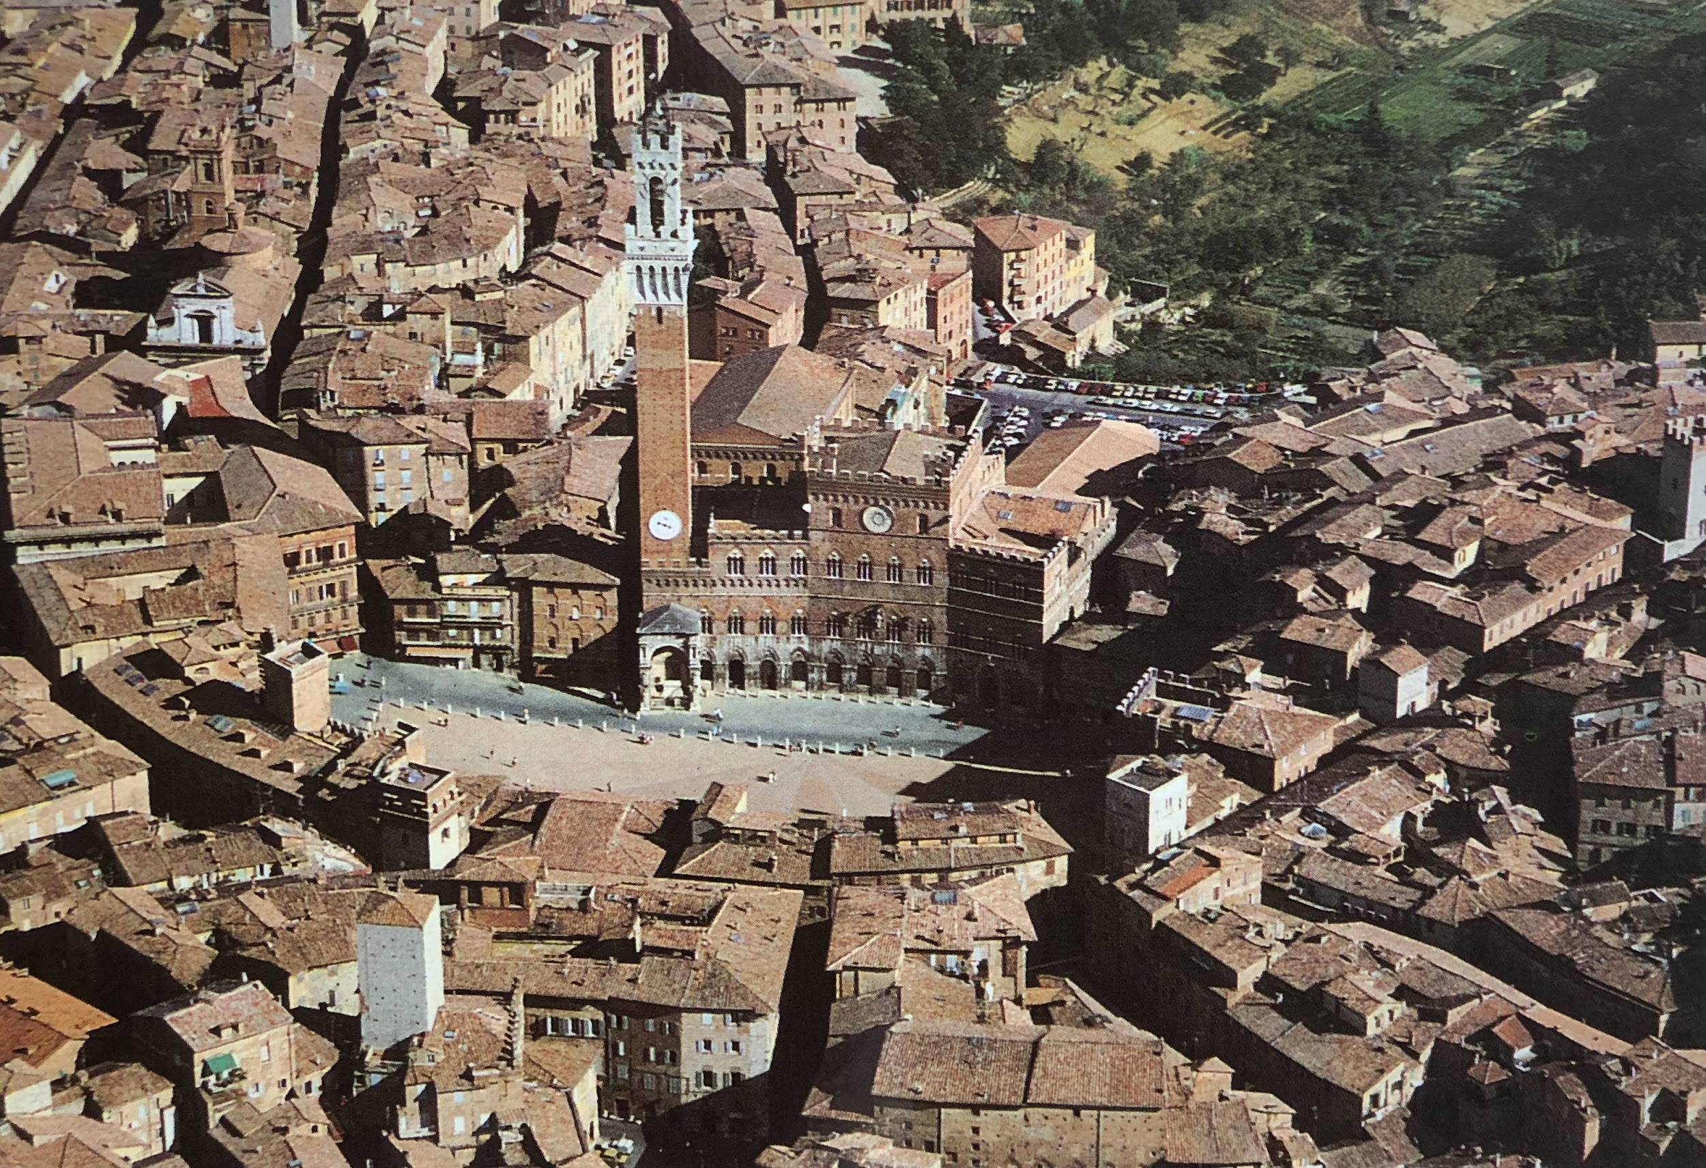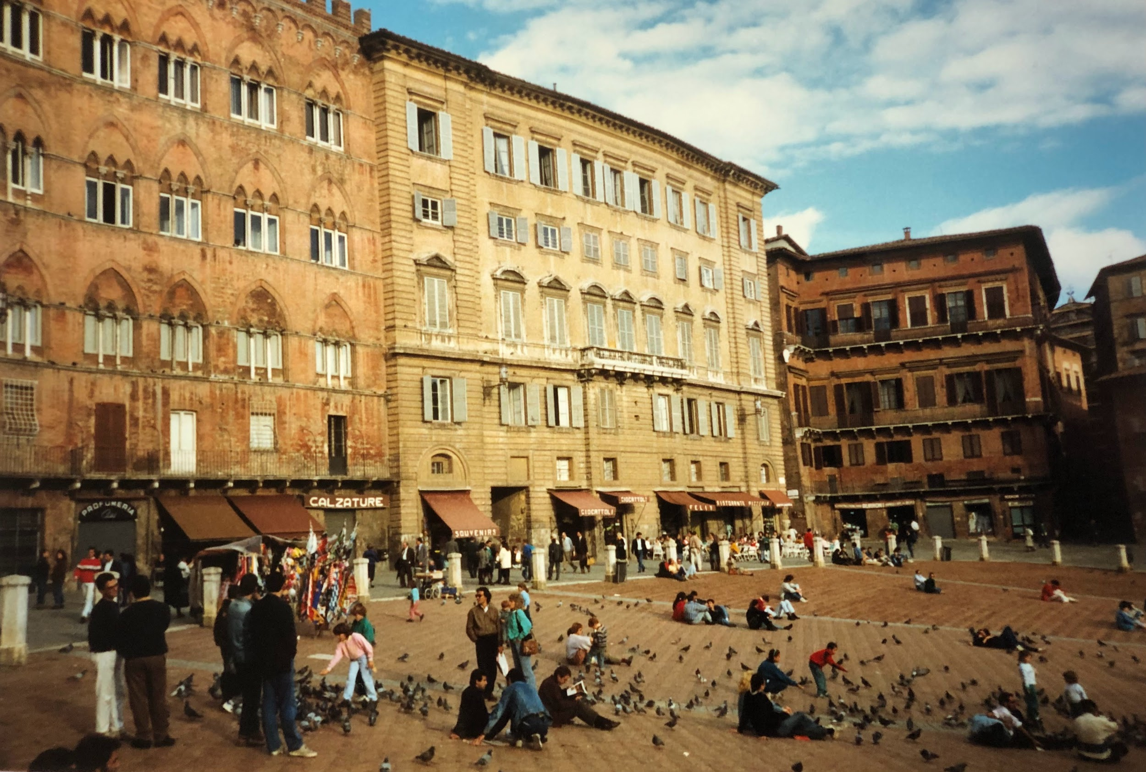

Eventually, I reached the Piazza del Campo at the centre of town. I sat on the stones of the square by the fountain to eat yesterday's fruit and rolls (thank you Livia!) and to drink Fanta. Piazza del Campo is beautiful, especially in the midday sun. I loved the building behind me with its ancient columned window frames and its Palio-viewing railings. An English college group and local children frolicked with the pigeons. A middle-aged French couple frolicked with each other.

Got up and wandered footsore to the Santuario di Caterina, a pilgrims' rest stop. Took a long time. Got lost. Eventually found it and got a single room for the night for 24,000 lire. Had a shower. Left various things out to dry out from the rain and the leaky Fanta bottle and collapsed for a short while.
Wandered out at about 5.10pm, saw the Duomo beautiful but darkened and with no mass in the afternoon. Went along to San Giovanni, the baptistry, and arranged to concelebrate there at 6.00pm. Rushed off then to see Duccio's famous Maestà (open 9.00am -7.00pm, much less restricted than last time), and bought a ‘I am a priest in mufti’ cross for my lapel. Crisis! My sweatshirt doesn't have a lapel! "Ecclesia supplet", Prof Bekes told us back at San Anselmo, so I breathed again. The church is enough!
Hey! I concelebrated mass with someone under 60! The goia! The sacristan didn't let me cramp his style though. He was one of those permanent deacons in all but ordination. After Mass I proceeded to the bus station and got far too much complex information spewed out at me from a computer print-out that wanted to paper-pulp me into wisdom. I edged my way round it and the man behind the counter told me what I wanted to know in four or five phrases and without the execution of a single sapling.
Went back to the Casa, worked out where I could and couldn't stop on the Magical Mystery Ralphroute, wrote some cards and ate some fruit. Telephoned home to wish my mum a happy 60th birthday and found out from the sisters that I could concelebrate at the 7.00am mass next morning. Went wearily to bed at 11pm.

Saturday, 30 October, Siena to outskirts of Padua. By bus, train and foot, day 3.
I'm sitting in a train in Ferrara looking back on the day (what a "Gita Book" entry this would make in College! Where are you now Liam Kelly, O Vatican broadcaster extraordinaire and victim of so many station-nameplate photographs?), today was full and now it's overflowing. It began with the 8.00 am bus to Florence (5,400 lire; the train costs 5,000 lire but takes longer than the bus time of 11/4 hours) after a concelebrated mass with the diocesan "Vicario" in front of the 13th century crucifix of the stigmata before which St Catherine shared the sufferings of the Lord.
Again today, the weather has been beautiful; pity the windows are misted over with condensation and dew. Still, it's beautiful Tuscan countryside - hummm ... zzzz. As I sat on the bus to Florence early this morning I said my prayers and read some of Paul Theroux's "Patagonian Express". When we arrived in the city I went directly to the convent of the Elizabettine Sisters in Via Orti .Sr Alessandra was on the door and Sister Pia Nazareno made me a cup of lemon tea. Sr Renata, the ex-Superior in Rome, looked fine but busy. So I left my baggage behind and went to find the church of San Miniato and the burial place of the Father Straker whose tombstone rests in the English College garden in Rome. Took the number 13 bus from in front of the station after picking up a free map from the station tourist office. The bus went anticlockwise to San Miniato, not direct as one might have thought. In doing so it gave a beautiful drive through the suburban green-belt, past the Boboli Gardens and on up to Piazza Michaelangelo (get out before the Piazza, at the foot of the steps, for San Miniato).
The most beautiful view of Florence there awaits your ogling orbs! Likewise, the view from up the steps outside San Miniato is no less exceptional, but no less so is that of the church itself. Beyond the Florentine-Romanesque facade (13th century) lies a church on three levels. Olivetan Benedictines are in charge; a sample conversation with one is worth recording:
(Me) Excuse me, Father, does this church have the Masaccio frescoes?
(Him) Who are you?
I am an English priest.
But no; you are a young boy, or a tourist!
I am all three.
But there are many priests in England of Italian parents?
Well, not too many but.....
No, they are all making ice-cream or selling pizzas.
Not all of them .....
Well, the frescoes are in the Carmine church but they have been subject to restoration for two years and will remain so for a year yet - don't worry, you won't see them.
Thank you Father, I'll see what I can do.

Anyway, the church is very, very beautiful. Even more so because it's up and out of overpopulated Florence. It has wonderful frescoes and a well-restored 13th century mosaic in the apse, a glorious crypt down below, a sigh-inspiring Annunciation, a Della Robbia chapel ceiling - etc, etc - and the body of the English College’s own dear James Straker. I was very happy to have visited his tomb and prayed for him so near to All Souls Day. The inside of the church is packed with systematically-organized 19th century memorial stones, Italian for the most part but many commemorating French and other nationalities.

Details from the Roman memorial stone, broken, near the so-called tank, the swimming pool in the College garden:

James Straker A.S.B; student VEC; priest of Clifton diocese; died 6 Sept. MDCCCLXVII at 27 years; buried in Basilica of S. Miniato outside Florence; commemorated by his sister Lavinia; A.J.M.C.M.; "Blessed are the clean of heart for they shall see God"].

I took a snap of Piazza Michaelangelo and jumping on the bus, left San Miniato. Got off at the Porta Romana, walked through Boboli Gardens and headed towards the Carmine (Carmelite) church. As predicted, the Masaccio frescoes were in restauro and will continue to be so for a long while yet, but I managed a quick peek at them through the plastic sheeting.

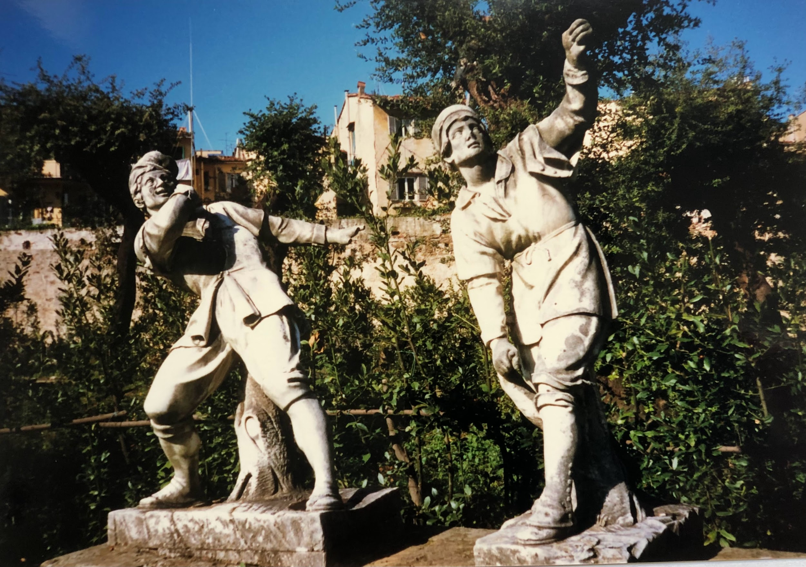

I mooched back to the Elizabettine sisters by way of the Santa Trinita Bridge. We were sharing a beautiful pasta, cutlet and potatoes lunch when who should turn up? Benito Colangelo as I live and breathe, a student from the college in Rome on his way to see his relatives for the weekend at nearby Empoli (San Miniato in Basso). We had a grappa-'corrected' coffee together with the sisters and I saw him off at the station, phoning his family in Empoli to say he was en route. I wandered over the Ponte Vecchio to Tourism Central. The area outside the Uffizi Gallery was still in an appalling state - graffiti, broken paving, corrugated iron and no sign of any improvement. In contrast, restoration is the order of the day in the nearby Piazza Signoria, a serious drive for Roman remains has led to widespread excavation. I hope they finish with a lick of paint for the whole locality.
Wandered in and out of the Duomo, stopped at Dante's Inferno and John Hawkwood's memorial and went on to the baptistry to see if the devil in the apse had chewed up anyone else since last time I saw him (what a sight!). Then to finish my tour of that area I took a pace or two around Dante's old stamping-ground. Finally I went on to San Marco but it had been closed since 2.00pm so I walked back to the station and persuaded myself to go to Padua rather than Bologna tonight.

With this in mind I telephoned two nieces of Suor Pia, the sister in charge of the Elisabettine nuns in Rome, to ask if I could take up their offer of a guided tour of their city. Katia and Roberta seemed happy with the decision, promising to meet me at the station at an agreed time.
Cheered by this news, I went back to the sisters for my bags and had a chance to chat with the old people there about the English College, my trip home... and my age, which seemed to interest them greatly. After another lemon tea with the sisters and a quick goodbye I dashed back to the station and a waiting train… which is coming into Padua even as I write!
The girls met me at the station and Katia drove us off to meet Daniele Santi, her boyfriend, for a pizza. Santi, as he was referred to, spoke Italian in the local dialect, said "practicamente" a lot, and made risqué references to my staying at the Ferins'. I liked him.
I loved the pizza. I had a Giaba (house speciality, pronounced "jabber") composed of a half-fried egg, sausage and mushrooms. Very nice too. I also had a meringue ice cream dessert (yummy) and a glass of prosecco to go with my wine (ah!). Soon after we went home to the Ferins and watched Adriano Celentano's ‘Fantastico’ show for a while. It featured a sweepstake about the colour of the garters that various models were wearing under their miniskirts. I can't have missed too much by not watching much Italian TV for the last years. And so to bed - their room kindly given up for me by the young ladies
Sunday, 1 November - outside Padua to Milan. By car, foot and train, day 4.
Woke up at 7.30am. Said morning prayer, shaved and met Mr and Mrs Ferin. When I kissed Mrs Ferin my glasses flew off. There wasn't a special something in the air, her glasses were too big!
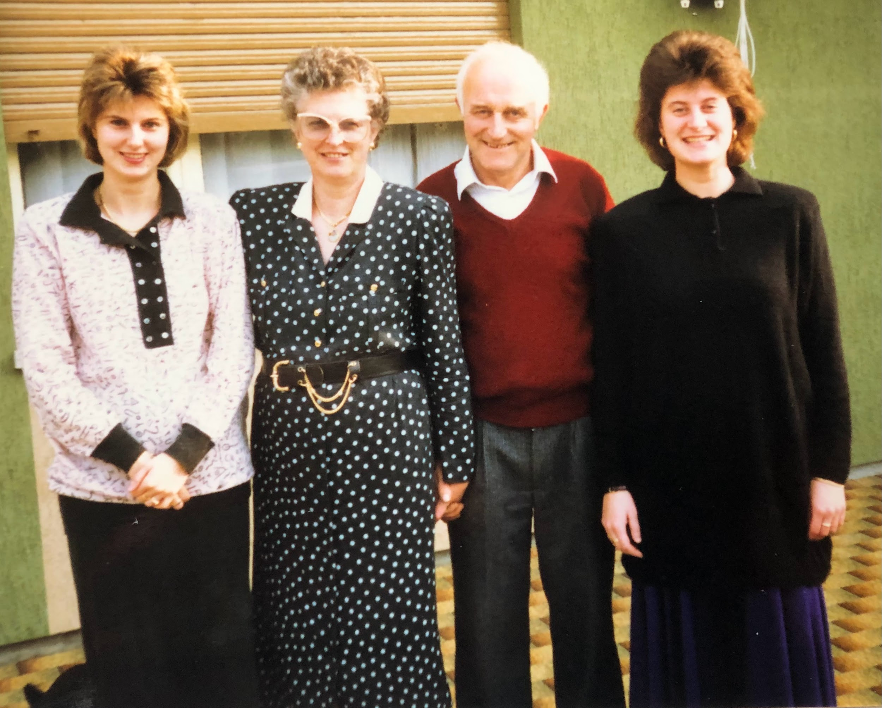
Had some tasty brioches for breakfast and chatted with the girls. They showed me their Roman holiday snaps from the times they had stayed with their aunt at the College, including the College pantomime. The context seemed a trifle odd: Jack and his beanstalks hits Sant’ Angelo di Piove.
After breakfast, on this All Saints Day we did what is traditional in Italy on this day, we went to pay our respects at the cemetery, remembering especially Flavio, Mrs Ferin's brother, and Suor Pia Celestina's mum and dad (the latter died in February this year).

I saw the girls making the sign of the cross, kissing their hands, and touching the graves ('drawers' in a 'concrete filing cabinet', Italian style), and connected it with the same gestures by a lady in the crypt of St Peter's in Rome some weeks before who was praying by John Paul I's tomb. The same gesture was also to be seen at St Anthony's tomb in the Cathedral later the same day. After that, and hearing about local Mafia connections, we went on to the church of Sant’ Angelo in Suor Pia's village.

When we went into the sacristy at five minutes before 10am to ask if I could concelebrate, Don Bruno (the new assistant to Don Guiseppe who had been there only forty days) gratefully decided that he would concelebrate and I could preside ("No, thank you, I don't want to preach"). After he had pointed out that the occasion gave the town an opportunity to be ecumenical, I gave the assembled throng a little warble about the College in Rome, its connection with San Angleo and also about my journey home. I also pointed out that I was a Roman Catholic, I thought that might help.

After Mass, Katia, Roberta, the obliging boyfriend and myself dashed off to Padua to give the Cathedral a swift once-over before I was to catch the midday train. We successfully managed a brief but memorable encounter with St Anthony's marvellously imposing premier place of devotion, prayed, bought postcards, took photographs and rushed off to catch the waiting train. As I hadn't lost anything in the process St Anthony said a relieved goodbye to me and went back to work retrieving the lost property of millions elsewhere.
Eternal life must be tough for a popular saint.
I was now on the train to Bologna, one of the finest cities of the north of Italy and a bastion of Italian Communism. After an hour or two, the train arrived at its destination and I was back on the ‘Ralphroute’ again. I only had two hours to play with before catching the next connection, so I checked in my heavy baggage and dashed off to see the sights, to buy the postcards, and to drink the coffee (as you have to do in all such places in Italy). I was very fortunate to find the imposing red brick cathedral open during siesta time and even more fortunate to find a kindly young and resigned Dominican who responded to my pleading and opened up the church of St Dominic to let me see the incredibly ornate tomb to that famous preaching saint who together with St Francis and others brought about a quiet reformation of the Church in the later Middle Ages.
Most of the other churches were closed and as the streets were quiet and there was no rain, I spent a pleasant few hours strolling along the arcades and marvelling at the enormous red-brick skyscrapers built as family status symbols centuries upon centuries ago. People don't change much. Eventually, I made my way back to the station and missed a train whilst searching a letter box so I could post a customary postcard to the college in Rome.

Looks like Milan outside - what a train journey! Missed the 15.38 train from Bologna by seconds, a second train was 40 minutes late and so I caught a third. That one was about two hours behind time because someone threw themself out of a train out near Modena... and then we met the Parma and Piacenza football supporters. Perhaps it's just as well that I didn't go to the former, looking at the batons, safety helmets and the sheer number of police (two in each part of the carriage: "Close all windows, close blinds - they throw stones"). Perhaps I wasn't meant to visit the hams of Parma. Don't like their cheese much so I'm not too broken-hearted].

Eventually we arrived in Milan where I planned to stay with a friend called Matilde. Not an Australian, as the name might suggest, but the sister of a Benedictine nun from Treviso (near Venice) whom I had met a year previously on a study trip to Ravenna. When I was passing through Milan on my way to Rome ten weeks before we had met up at the station, and she had offered a port in a storm for my journey home. My only problem was to locate her flat. I had instructions regarding which tramcar to catch but got off too early. After staggering around with my luggage in the less-than-twilight I got back on the bus again and arrived at the stop I had originally intended to reach. Matilde's flat was only minutes away and soon we had settled down to some delicious 'pasta al pesto' and tales of the Ralphroute thus far. Finally night called an end to the evening, she had to be up early for work in the advertising department of a bank and I had a morning of exploration before me.

Monday 2 November - Milan to Turin. By foot, train, bus and hitchhiking, day 5.
The next morning was taken up with a rush around one or two of Milan's most beautiful churches. My prime intention was to see Santa Maria delle Grazie, nearby to which Leonardo da Vinci's "Last Supper" is to be found; fortunately it was easy to find and I discovered to my pleasure that the church itself has a beautiful cloister. The "Last Supper", which is sited in the old monastery dining-hall nearby, was miraculously saved from obliteration during the bombing of Milan in the last war. All that was left of the refectory were the two opposite end walls, one covered over with a fresco of the crucifixion and the other featuring the "Last Supper".
Even today the restored room has a bare and shell-shocked atmosphere, the unease augmented by a turnstyle (tickets 5,000 lire each, Italian passport holders free - so much for the universality of art), and by continuing restoration of the masterpiece. What did I think? It was a bit like seeing a good friend in an intensive care unit; I look forward to seeing the patient in good health and in comfortable surroundings. All the same, it's a nice little parable about the fragility of beauty.
From there, I made my way over to the church of St Ambrose, where St Augustine was baptised by Ambrose after decades of searching for the Christian God. Its beautiful courtyard and uncluttered interior made it one of my favourite churches in Italy. It was also good to return there as it reminded me of the last time that I had been there, only months before when I returned to England with Charles Briggs, Rags Hay-Will, Nick Hudson, Mike Raiswell and Ant Towey. Some of us had nipped down to St Ambrose's after mass in the Cathedral. We had been fortunate enough to celebrate mass together in the crypt of the "Duomo", along with three other English College students on their way back to England. My concelebrants were returning to England to begin their work as priests and so it was only fitting that, like their forebears four hundred years before, they should seek the blessing of the Archbishop of Milan. St Charles Borromeo obliged in the 1580's and Archbishop Carlo Martini did likewise in 1988. Fortunately, we were able to catch him in the cathedral after he had paused to pray at the tomb of a former Archbishop. A brief encounter, but full of symbolic worth.
And so, having returned along to St Ambrose's, I took the next step, returning to the Cathedral where I presumed I would have a moment or two to say a prayer. When I arrived, however, candles were alight on the main altar and the time was two minutes to twelve. I made a sprint for the sacristy and with the help of an obliging sacristan, processed out on the stroke of twelve to concelebrate for the waiting shoppers, tourists and office-workers. I had stopped at Milan off and on in times past to ask the blessing of Charles Borromeo on my search for ministry, so I can only presume that he was smiling at me at the time. You're never alone with the communion of saints around!
After Mass had finished, I dashed around to the superb sandwich bar behind the Cathedral (on the left at the beginning of the arcade), picked up a couple of scrumptious little wonders and rushed back to the main railway station where just enough time was left to catch the train to Turin. A brief flit through Milan, but not uneventful!
The train journey was long enough to give me time to eat my sandwiches, have a short nap and say some prayers, but short enough to get me to Turin by mid-afternoon. The city itself held little interest for me on this occasion, I was more interested in a tiny village miles out of the city, the village where the priest I would like to be more self confident, care less about others thoughts, less paranoid.Don Bosco was born, the village of Castelnuovo. Unfortunately the great throngs of Salesians, religious and schoolchildren, who were inspired by this popular educator of the poor do not merit a direct bus or train to their founding father's birthplace. Consequently, I had to walk across town to a bus station and catch a departure for Chieri, the nearest large town to Castelnuovo.
I spent as long in Chieri as was necessary to take a photograph of a plaque commemorating the cafe where Don Bosco worked as an adolescent waiter, and to walk out of town to a point where I could hitch a lift in the direction of Castelnuovo, which was still many miles away. The busy home-going traffic showed very little interest in stopping for me, but after a while Don Bosco must have smiled on me because a kind old man who stopped to give me a lift happened to want to go all the way to my destination, an inclination not all together divorced from the fact that his son had spent a few years in a religious order before deciding that the life was not for him. Kind of dad to bother with me. I hope it didn't make him late picking up his daughter from work.
It was dark by now and everything was closed, but an obliging elderly priest, complete with full-length soutane and beret, opened up the enormous new basilica towering on the top of a hill visible for miles around to let me see how the saint's humble birthplace was now a place where thousands of people gathered from one end of the year to the other to thank God for the presence of the Spirit who guided Don Bosco to increase the faith, hope and love in their lives, and to ask God to inspire them with the same Spirit. It was a particularly appropriate moment for me to share that prayer. Back in London my old school, Salesian College Battersea, was celebrating its centenary. That same school was the last of Don Bosco's foundations before he died in 1888.
The only object of particular interest was a plaque on the station wall remembering the English engineer Stephenson's contribution to the development of the Iocomotive. I didn't dally in Castelnuovo as night had fallen and I wanted to be sure of accommodation overnight. The only thing to do was to hitch back to Chieri. The becassocked ancient sprang to my assistance and persuaded a mother and child, who had come up the hill in the hope of finding mass, to carry me as far as they could to a local village. They graciously complied. When I left them I tried a second time, having had no success on my arrival, to contact my host in Turin.
Still no luck. I left a message. I had been told that a bus would come after an hour and so I sat in the coffee bar biding my time, watching the antics of the real-life Italian version of the Rovers' Return and telephoning from time to time only to receive no answer. Finally, I decided to make a move and to see whether a spot of hitch-hiking would be a more profitable way to pass the time. It was. A kind and long-suffering mum with marriage problems picked me up and we had a very involved conversation about the mystery of suffering, an experience of which she had had more than her fair share. She still believed in God but she wanted time to air her grievances - don't we all? Such conversations are the high points of hitch-hiking, people feel free to speak frankly to somebody they will never meet again. Perhaps there is a religious ministry waiting to be done out there on the motorways by an enterprising Christian individual or group. Dangerous in some ways, but well worth it.
The kind lady took me as far as Chieri, where I caught the bus back to Turin. After a little useless wandering, I found a telephone-box and managed to get in touch with Don Vigilio, my kind host from the Rosminian Congregation, another group of religious involved in secondary education. Don Vigilio "cut the waffle", as he was wont to do, and told me it was far too complicated to get from where I was to where he was by foot late at night and that I ought to get a taxi. I complied, arrived at his house, and was ushered in to eat a late supper with another priest who had also been "on the road".
I like Don Vigilio; in some ways he was a crusty and hard-bitten old-timer, but the things he did to welcome me at such short notice - on his brother's recommendation - showed his true mettle. He had worked with school children for most of his life, some of his best years had been given as the headmaster of the school next door. My favourite line of his had to do with the great number of young friends he had made through taking groups of children on language courses to England: "There are too many of them! Oh yes, like everyone else,I used to like to keep in contact. Nowadays? I beg them to believe me dead!" The poor man had retired some years before to a quiet life in peaceful Domodossola but the school in Turin had gone through such a rough patch that he was called back to restore morale and set things on an even keel once more. It was almost more than he could bear, hence the occasional flash of black humour. We eventually went for a walk, found an open coffee bar after some effort (at 10.00pm, dozy these Turinese) and bought a bus ticket for the next morning.
After a long day and with great plans for the morrow I rushed home to bed, switched the alarm on and switched my brain off.
Tuesday, 3 November - Turin to Geneva? By foot - trekking in the Alps! -, bus, train and hitchhiking, day 6.
The alarm switched my brain on again bright and early next morning and after a shave and a prayer, I dashed out with Don Vigilio to catch the bus, bidding farewell to the genial old buzzard who will buzz on for quite a few more years yet. I arrived at the station without incident, caught the train for Modane and beyond, and after a while took out my notebook to record a fleeting moment....
"We are just about to leave Italy; my passport has just been checked. If another official comes, , I will tell him he can have my wretched residence permit I queued so long to achieve! Ciao Italia! It was beautiful but now it's over (as Humphrey Bogart might have said, stubbing out a last cigar).
Thank you also to the young girl who has just posted an urgent letter to my bank manager - the smiling face of beautiful Italy - Italia bellissima!" (the girl, not the bank manager).
Well, I arrived at Modane in France and caught a train to St Michel, from where I wanted to walk to St Jean de la Maurienne (Modane to St Michel, 17 km; St Michel to St Jean,14 km). As I wrote:
"No sign of the 'winding river Arc' just yet; it must be down there somewhere - oh, there it is, meandering away just like me! The sky is so blue! The sun is out but there is a mountainous nip in the air. I am so pleased that this train exists! At this rate I might even get to Annecy, the birthplace of St Francis de Sales."

It looked a pretty bare and poor valley. Pylons for power generation and distribution seemed to be the name of the game.
"Well whadd'ya know! The river seems to be flowing on either side of us, like Italian traffic (he said nostalgically). I hope my knee tendons hold out (I rubbed them "tendonly" to encourage them this morning). Are they convinced I care for them? Do I care for the need of all my members, every legation? (warble, witter...)".
There are shadows on the glen... enter John Houston and Clint Eastwood. Another tunnel.
"Raylf and the boys must have had problems digging their way through. Was he a Yorkshire miner?
Probably not. Just saw a sign for St Jean. Alors! (Not allora any more)".
I got off the train at St Michel Valloire and went to the ticket /info/baggage office, three windows and one helpful person running it all. She sent my rucksack through to Geneva for 32 Swiss francs, very reasonable. I then discovered that I could go to Annecy after all, and get back to Geneva at a reasonable time before nightfall! Jolly dee!

So, I traipsed off down the road towards St Jean passing an odd sign which said "Welcome to St Michel!" (just as I was leaving it), and walked on down the main road with strong sunshine on my back. A cloudless blue sky and many craggy mountains towered over me, one of which had a line of exhausted-looking trees on its crest. After a while, I found I was able to avoid juggernauts by following an older road on my left which skirted the right-hand bank of the river. After a while this packed up, the result of earth-moving operations ("I feel the earth move under my feet, I feel the sky come tumbling down", thank you Neil Sedaka). It must have been to do with the hydro-electric power schemes that supply the numerous industrial developments on either side of the river from here to St Jean and beyond. Well, I walked on. For a while I had to walk along on the stones skirting the railway line until I could get back to the minor road. The main road would probably have been quicker but more stressful. I wondered along thinking of Ralph and co. and the separated lady who gave me a lift from Castelnuovo to Chieri yesterday. I remembered our chat about the suffering of Job and the ideal Father-God who seems to have feet of clay when it comes to the pains of innocent people. I also thought about Don Vigilio and his "Via Crucis" (Way of the Cross), and also about my contemporaries who are working in English parishes. I remembered the ministry of the suffering Christ himself and prayed the Rosary for one and all.

In time I reached St Julien de la Maurienne and felt rather pleased with myself. The only problem was that I had arrived at about half-past midday and the whole town, apart from a supermarket, seemed to be closed. I strolled around the plush new shopping precinct and the older medieval alleys but without any luck at all,all the bars seemed to be closed and not even the tourist centre was open; the streets got more silent with every passing moment. (No kind reader, this isn't the ghastly overture to some dastardly shock horror! It just felt like that to my poor undernourished frame). Eventually I ended up tucking into a gigantic French-stick in a transport cafe on the outskirts of town. Fortified by my late lunch I had another stroll around town and inspected the brochures which invited me back to ski when the snows came. That thought in mind, I made my way to the railway station and headed off to Annecy, stopping only to glance out the window at Aiguebelle as the train sped by. Four hundred years before Ralf and co. had stopped by at Aiguebelle to sample the hospitality of the Carthusians there. It was good to relax on the train, satisfying to think of the day's events, and marvellous to be heading on to Annecy.

Well, what can I say about Annecy? A lightning visit, one hour long, gave a real delight to my eyes and mind, even now as we are moving away from it on a fast train to Lyon (I'm getting off at Aix-les -Bains). The area is beautifully wooded. We've just passed the river... twice, three times, four times, winding deep below the railway line. Annecy reminds me of Strasbourg and Venice on a small scale, with the river flowing like a canal through the middle of town. I crossed it twice or three times going back to the station. What I really liked was the island-church that used to be a prison!

"And so the sun goes down on the evening mists of Haute-Savoie. We say farewell to Annecy! Farewell to the Cathedral of St Peter where Jean-Jacques Rousseau used to play his little flute in the parish orchestra and where Francis de Sales' confessional still stands. Farewell to the church of the Sacré-Coeur where Francis' father came to pray for a son and where many years later a white dove was seen to descend on that son's head as he celebrated mass as a bishop… Farewell Annecy, city of a host of bridges decorated with a myriad of potted plants on both bridge and river bank. We do not say "adieu" but… (pause).... "au revoir" until next week on Wicker's World."

So, I carried on down to Aix-les-Bains, and tried to phone through to Geneva to book a room for the night at the Jesuit hostel, unfortunately I had no luck. As I ran round frantically making sure not to miss the connecting train I had further bad luck on the comestible front, little was available. Finally I bought some orange juice (at an extortionate price, 1 litre for about 11 francs) and proceeded to gorge myself on it and the remnants of Milanese Matilde's 'bon voyage' cake. After a short journey we were soon in Geneva. I immediately phoned Sr Marie-Thérèse at St Bonifatius' hostel but sadly she wasn't in. The other sister, however, said that I could come if I got there soon. I did and I did.
Before going to bed, despite aching feet and knees, I felt obliged to wander round and undertake whatever theological disputations were on offer! This was a very traditional aspect of the journey as Ralph Sherwin and friends had gone out a-disputing at the first chance to out-quiz the shock troops of the Protestant reformation on their own ground. I walked up to St Peter's Cathedral, used as a base by Jean Calvin, went on down to the lake, and stopped by at MacDonalds where a kind Asian assistant paid the half-franc I couldn't afford for my filet o'fish. Much appreciated. Walked back to the hostel past two life statues of shopping and commuting city folk near the Avenue du Mail bus centre. My feet felt as leaden as theirs: I sank into bed almost crippled.
Wednesday, 4 November, Geneva to Dole. By train, hitchhiking and host’s car, day 7.
I woke up at 6.15am in the oddly-named Home, the Youth Hostel of St. Boniface's parish in Geneva. Shaved...oh no I didn't ! My things were at the station (so I thought). Anyway I said morning prayer and went and concelebrated mass in German for the feast of St Charles Borromeo with the Jesuit priest, the lay-brother and the sisters. After mass the priest-chaplain showed me the route to the next stage of the trip, the solitary town of St Claude where Campion, Sherwin and co. went in a spirit of penance after their Genevan adventures. The journey would have to be by train via Bellegarde and Nantua. Unfortunately there were no direct trains or buses to St Claude.
After breakfast I headed off to the station, bought a ticket to St Claude, and went to claim my bag - poor innocent abroad! Little did I know it would take two to five days for the bag to make its way to Geneva. That bad news complemented the fact that the station Information girls were in remarkably bad humour, throwing timetables around, seething with frustration and drawing a cry of ‘Merde!’ from at least one frustrated passenger. Makes you believe in evil spirits…

'Well, I said to my father (biblically) "I will leave this place and go to St Claude" by train via Bellegarde and Nantua, so I thought. When I arrived at Bellegarde at 10.15am I was informed that the next train was at 5.45pm. I decided to hitch-hike (no other choice) and as it turned out God smiled on me in the form of a Portuguese cheese -worker called Aurelio, a forest transporter (yes a forest transporter), and a Japanese "Nissan" worker on his way to St Claude to help set up a factory.

I arrived in St Claude in time to see the Basilique just before it closed. St Claude's body was destroyed by the 18th century revolutionaries, as were many of the 15th century choir stalls, the finest in France. Beautiful stained glass too, the 'repristinated' pure gothic looks almost new.

All this was fine, but two problems were not far from my thoughts: how to get out of St Claude, and how to get my luggage back from Geneva (if it had in fact arrived there). Leaving these imponderables to one side I went to find something to eat at "La Columbey", on the left heading towards the main square (near the post-office and tourism centre). I sat down to my 30F "plat du jour" and local white wine and was smiled at by the lady sitting next to me. I ate my meal in silence, stopping only to speak to the girl opposite, a sentence to check that I had actually seen the 'historic centre' of town.

After a moment the lady next to me asked in English if I liked the local wine. I was a little taken aback at first, but soon we were chatted away like old friends. I couldn't understand how quickly she zeroed in on the fact that I was from England, rather than any other English-speaking country. The reason was that Sylviane had lived in England for many years, in Derby. I told her about my plans for "the escape from St. Claude" and how I had to go back to Geneva for my bag. It was then that she offered me the chance to go back with her and stay with her husband Michel and herself in Dôle, north of Dijon. Somewhat surprised, I arranged to meet her in a couple of hours to let her know my reaction, yes or no. In the meantime I wrote postcards and went back to the Basilica to pray midday prayer. After the interval, we met up again and after an abortive attempt to phone Geneva about my bag we headed off to Dôle. After an interesting chat in the car we reached our destination and I wandered off to see its minor basilica (église collegiale).

On the way back I bought some wine for supper and a bunch of flowers for Sylviane. I met Michel her husband and we shared a simple and satisfying supper enlivened by ice-cream and cassis! Had an interesting chat about why I was a priest and why so many Catholic French people no longer go to church. Went to bed exhausted (as usual).

Thursday, 5th November, Dole to Dijon. By hitch-hiking and train, day 8.
Woke up at 7.30am. Morning prayer - shave - breakfast - photo - fare thee well! Decided to hitch back to Geneva but had a very slow start. Eventually a school-teacher picked me up, then a man with two sons, a road-sign transporter from nearby St Laurent, a speed merchant, an elderly Belgian retired lady, and a cosmopolitan pair of young people with a liking for Senegalese disco music who kindly dropped me outside Geneva station... phew! ... God helped too!

And whadd'ya know? My rucksack was actually there, waiting for me! Ah, the joy of reunion! So, I posted my customary postcard and rushed for the train to Lausanne. Sadly a pedantic customs official took my desire to catch the train as a sign of international wickedness and made me go back to the end of the queue and have my belongings searched. At the end he asked: "Are you a student?". I, stifling my fury at being made to miss my train, uttered the immortal Ralph Sherwin-like words, "Je suis Prêtre" (not that it made much difference to him, could have said "Je suis trapeze artist" for all he cared). Much to my surprise the train was still there when he had finished with me. From Lausanne I caught the
connection for Vallorbe.
Vallorbe, 5.45 pm
I'm sitting in the station buffet waiting for the train. I'll have been here for two hours by the time my train arrives. The buffet is called ‘Chez Eric’. Eric actually came up and shook my hand (and everyone else's) a while back. The waitress is quite friendly too, doesn't mind at all that I've my bits and pieces scattered around me like a dissertation back in the College library. I think that she's happy because a customer took her picture with a polaroid and has given her a copy. There seems to be a satisfied and content working atmosphere.
The valley of Vallorbe forms the Swiss/French border. It looked very beautiful as we came in on the train; the colours of the leaves, red and orange ochres, were spectacularly, breathtakingly fiery. It was the same in the Jura this morning whilst I was hitch-hiking, but that's another story, as you have heard...

Later.. Well, I caught the Vallorbe TGV. It was a bit loopy in Eric's just before the 6.24pm departure. At 6pm the people serving in the restaurant started assembling cutlery and comestibles. As I'd only had a grapefruit, a little bread, a coffee and a sandwich to eat all day (not to mention all that mountain air) I was intrigued. The friendly and obliging waitress (not) had previously assured me that nothing would be served until 6.30pm, after my train had gone. In short, I ordered some chips and they arrived, complete with table service, cutlery, bread and serviette, nine minutes before departure time: an enormous plate and a doubly-enormous serving of chips! Sadly no doggie bag was in sight and I didn't think of suggesting one. I wolfed away with bemused concentration for five minutes, getting through half the chip mountain, but then I had to go for my train. Surrendering the groaning remainder to “Favourite Waitress 1987” I dashed off.

Again the train didn't leave without me… I got as far as Dijon before that happened. The idea was to change trains at Dijon for Rheims. Unfortunately, the transition was too tight. The Vallorbe train arrived at Dijon at 7.48pm and the Dijon to Rheims train was to leave at ...7.48pm too. And it did. Pretty frustrating, as you can imagine. It had been my intention to arrive at Rheims at about 11.30pm and stay somewhere cheapish where I stayed on the July trip. I wanted to get up early to celebrate Mass somewhere local, then catch the 8.47am train and arrive at Trier that morning.

But lo! All was not lost. I saw on the notice board a 4.45am train from Dijon to Rheims arriving at 8.30am, just enough time to buy a ticket to Trier and to catch that 8.47am departure after all. With this in mind, I made my way purposefully out of the station and went to look for somewhere to spend the night. As it was gone 8.00pm I didn't bother looking up any religious houses, just chose a cheapo 1-star place near the station called ‘L'Étendard’, stopping en route to buy some wine for my hosts tomorrow. The room was fine, though the soft bed didn't do my back much good. The fact that it had a shower and I could freshen up after two days without my rucksack was much appreciated. I showered and went off to sleep before my head hit the pillow. Then I said night prayer… ish.

On the earlier Ralphroute in July, our party of six stayed at the Hotel Bristol in Rheims and celebrated Mass in the side chapel of the Cathedral. We sang the College motto, "I came to send fire to the earth..." as the Alleluia verse. It was there that I now came across this prayer of the Diocese of Rheims for 1st December, the feast of the Bienhereux Martyrs Anglais, the Blessed English Martyrs:
"Les bienheureux martyrs que nous fêtons aujourd'hui ont quitté le refuge de notre ville pour ramener leurs frères a l'unité de la foi;
Accorde-nous,Seigneur, à leur exemple,
d'abandonner notre tranquillité pour annoncer ton nom à ceux qui te cherchent,
Par Jesus Christ."

In English:
“The blessed martyrs that we celebrate today
Left behind them the refuge of our town
To bring their brothers (and sisters) back to the unity of the faith;
Give us grace, Lord, by their example,
To abandon our tranquillity and proclaim your name to those who seek you,
Through Jesus Christ”.

Friday, 6 November, Dijon to Trier. By train, foot and hitchhiking, day 9.
Woke up quite sometime before the lark (3.40am). Prayed and tidied things up. Felt reasonably fresh as I had got to sleep at about 9.45pm last night. Headed out to the station in the cold and misty morning air, fog and frost were certainly in charge but my tee-shirt, shirt, jumper, track-suit top and raincoat helped me to cope quite well.
The train was waiting. I discovered that the 2nd class non-sleeping carriages for Rheims were at the very end of the train and decorated with assorted bodies strewn along all the available corridor space. Didn't really bother me as they looked quite comfortable and I wasn't really thinking of sleep. Prayed the office of readings nice and slowly sitting near the end doors of the carriage as we trundled through the night. Eventually we stopped at Obscuritania-Centre Ville to fool around with the carriage coupling. The train was splitting in two, half for Rheims, half for Metz. Well, it took them a while to work out how this would affect emarginated corridor-dwellers and an even longer while to actually complete the shunting of carriages from A to B to C. I only had to move twice and ended up with a nice compartment of eight seats to myself. It was about 6.10am and I was feeling weary so I set my alarm clock and stretched out for a kip. People came and went for two hours but all in all I had a good old doze. My only disappointment was to come in the form of a long delay outside Rheims, with the result that we arrived in town a quarter of an hour after the train to Trier had left. Whether it left in time or not I don't know, but it left without me.
All this considered, I wasn't feeling all that well-disposed to Rheims. In fact, having seen the Cathedral when we stayed overnight in the summer, I had no particular reason to stay, particularly as all the automatic luggage lockers were broken or booked and the baggage department was charging three times the locker rate to keep an eye on them. I was feeling "under the moon, Brian" and opted to have breakfast and to catch a train going some of the way towards Luxembourg, in the Trier direction. The alternative was to wander round town with a worsening backache and catch the direct train in the afternoon. A simple choice.

Had coffee and a huge croissant and caught the train to Charleville-Mezières. My luck was in, there was a connection for Sedan; but at Sedan (where I arrived at about 11.45am) there was nothing further until the mid-afternoon connection for Longwy on the Luxembourg border so I wandered out of the station to hitchhike instead. As I was waiting to cross the station forecourt, I asked a middle-aged woman accompanied by a bespectacled adolescent whether she could point out the road for Luxembourg. We exchanged a few sentences in French and then she started speaking English with the kind of accent I could only associate with Spanish children who go to learn English in Dublin. We crossed the road and she offered to walk with me and to point out the right direction when our paths diverged. It turned out that she was Irish, from Belfast, and had married a Frenchman who came to Belfast on holiday over twenty years before.The young man was her son, Bruce. Soon we came to the road for Verdun and said goodbye to each other, but I had hardly crossed the road when Bruce came running up behind me to invite me to walk a little further and share lunch with them! Flabbergasted by a seeming repetition of the Dôle experience, I agreed without too much persuading.

As we walked along past the butchers and the castle and on to their home in a nearby apartment block, Margaret told me about her husband Michel, her involvement with her local church, and her work as a part-time translator. The family and I got on very well as we chatted over a beautiful meal and the nice bottle of wine bought last night in Dijon, our happiness came not only from a shared enthusiasm for things Irish, but also because the family had recently holidayed together in the Jura mountains near St Claude.

Primarily, however, we shared a common interest in the Church and its different forms of local Christianity; in fact, Margaret made me a present of a book introducing children to the Christian heritage of their area. A fine time was had by all, photographs were taken, and Margaret and Michel even came to see me off at the station on the afternoon train to Longwy. As I sat in the train reading about the Champagne and Ardennes area and gazing from time to time at the beautiful autumn forests of the Franco-Belgian border I thanked God once again for the many kindnesses I've experienced on this twisting, tortuous journey - from Himself and from his people.

Well, arriving at the end of the line at Longwy I found that again there was no option but to hitch ("faire le stop"). After walking a fair bit away from the centre of town and holding my little "LUX" sign out to all-comers I was eventually assisted by a true Luxembourgeois (a Luxemburger, but without cheese), a rare species. He was from Ezch-sur-Alzette, Luxembourg's second city. Surprised that anyone from England could speak even a little French, he was eager to talk about his country and the last war, in which he lost a brother. Though he was very informative about the local economy, he was not too hot on local geography, I'm convinced that he put quite a few extra kilometres on to the distance by the time he left me at Ezch-sur-Alzette station. Nevertheless, the locals were very understanding, changing my French money with no fuss and directing me to Luxembourg City. There I changed more money for the train ticket and for a replacement bottle of wine, I phoned my hosts in Trier, and promptly caught the train.

Arriving at Trier station I was met by my good friend Martina, a theology student who used to attend the English College Sunday Mass,and we walked for a few minutes through the thick and freezing fog to her family's home, where I stayed overnight. I got to know them all quite well last summer when I spent three weeks forty miles from Trier as supply priest to a beautiful parish on the river Mosel. Acquaintances were renewed, we ate and chatted and eventually I went off to bed - exhausted as usual. Seems to be the only way.

Saturday, 7 November, Trier to Amien. By foot and train, day 9.
I dragged myself out of bed next morning and Martina lead me to the beautiful nearby church of St Gangolf, run by the Redemptorist congregation. I was happy to concelebrate mass on the feast of St Willibrord, the English missionary to the Low Countries. His memory is still celebrated with the famous and very silly ‘hopping game’ that takes place in the town of Echternach every Whit Monday (don't miss it). What a wonderful way to remember someone!

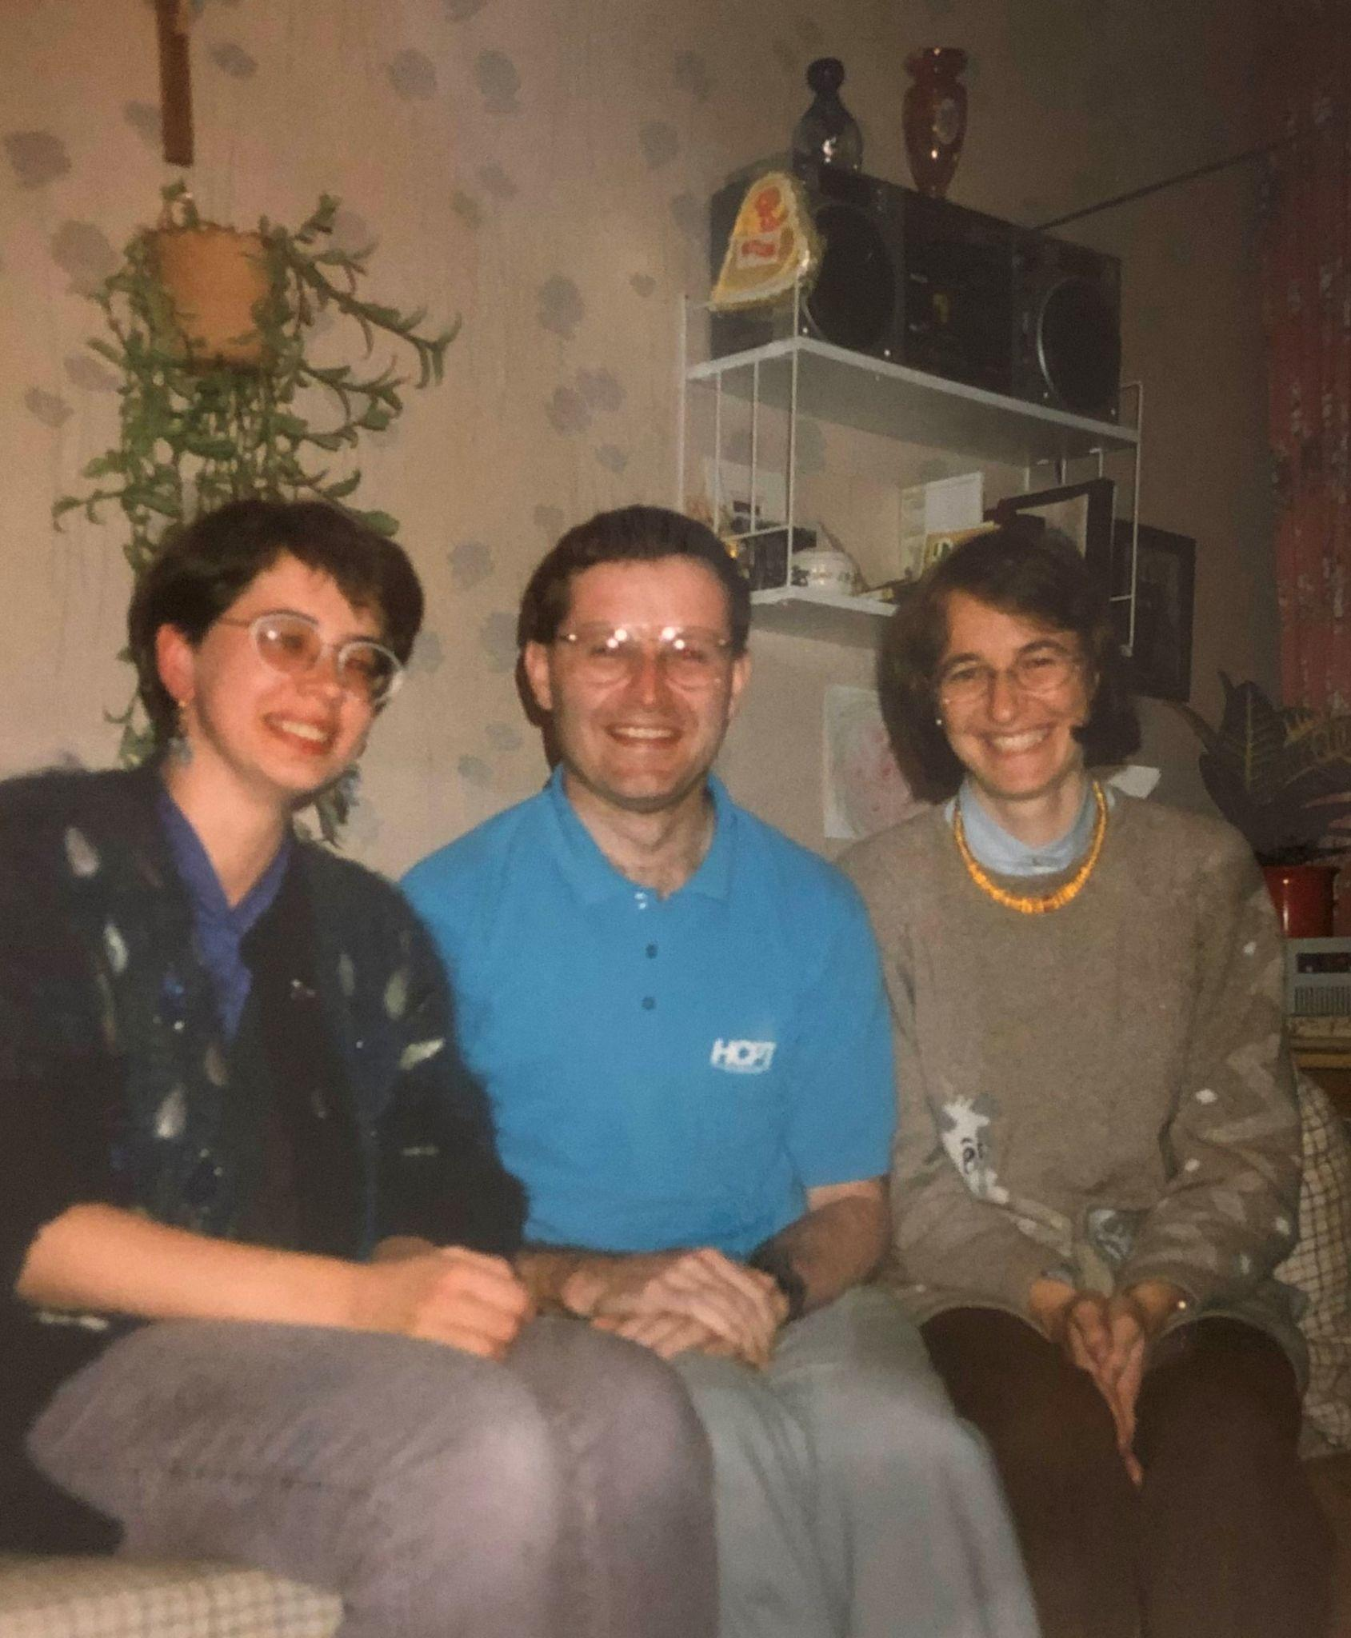

I spent of the day chatting and snacking happily with the therapeutic Düntzer family. After a gargantuan lunch and several sticky buns we had to say our goodbyes. Peter drove me to the station for the afternoon train, where I said my goodbyes to Martina. Soon I was heading back towards Rheims and Paris, scribbling as I went…

"This train is bound for Rheims now, this train ....." It's also bound for Paris. At the moment, I'm wondering which town, if either, I'm bound for tonight. I need to get to England tomorrow, but before that I want if possible to go to St Omer, near Calais. If not, I could go to Douai as we did in July..·Come to that, I could stay overnight in Rheims... The trouble is that there aren't many trains tomorrow, Sunday, so I'm as well to get as near as I can to the Channel...

“The Ralphroute didn't go through Paris, because of fear of informers watching out for their coming and going. It didn't go through Douai or St Omer either as those seminaries had to be evacuated to Rheims because the wars of religion were raging. I'm wondering if the ticket folk will allow me to use my Rheims-Calais ticket via Paris, if so I'll do that and try and get from Paris up to Amiens or Lille tonight…”

The ‘ticket folk’ did indeed let me pay the difference as far as Paris, and from there I decided to go on to Amiens. Arriving in Paris, I dashed from Gare de l'Est to Gare du Nord before any Elizabethan informer could notice that I was in town, picked up a hamburger and a coffee at a friendly African takeaway, and took my seat on the last train to Lille. It was a pretty groggy ride, made more tense by the fact that even though I was dropping off to sleep the last thing that I wanted was to miss the stop at which a connecting train to Amiens was waiting.
Eventually we arrived at the connection, caught the train for Amiens, and reached there at half-past midnight. By now, it was freezing and I was looking for somewhere, anywhere, to stay. Met a Brit in similar shtook in the doorway of a cheap hotel, but there was no sign of life. I wandered off to find an alternative, which took some little time. I rang the bell and the proprietor came down in his pyjamas with the look of a man who had done so three or four times already and found it perfectly natural. He even managed a sympathetic smile as I counted out the pathetic dregs of my French currency, giving him 105 francs (about £10) and keeping the remaining 5 or 6 for myself. With a bleary "Bon nuit" I staggered up three flights of stairs and set my alarm clock for 6 am so that I could get up for early mass at the cathedral and buzz off to Calais as soon as possible.

Sunday, 8 November, Amiens to Battersea. By foot and train, day 10.
My early morning arising wasn't to be. I woke up 3 hours later at 9 am. Cheesed off to have overslept I shaved and said morning prayer, and resigned myself to a quick shifty at the Cathedral, which was only 5 minutes away. Though I did not have time to attend Mass there, I thought at least I would see the sights before rushing for a train to make the crossing to England in time for an evening Mass.
As I entered the Cathedral I was surprised that so many people were going in at twenty minutes before ten. I followed the stream of traffic over to a side chapel where lighted candles were waiting on the altar. The sacristan nodded when I asked if Mass was being celebrated now, and seeing my collar he hurriedly pointed out the sacristy. In I dashed, with plastic bags and a bemused and demeanour. I interrupted a conversation between the administrator and the aged and venerable Dean, who were about to receive the nod from the MC which would start their procession to Mass at the side chapel. I stammered a few words about being a priest from England who wanted to concelebrate and my request was met with a warm and patient welcome. Within moments we were standing together at the side altar at a solemn but cheery Sunday Mass with a parish community that had something extra to celebrate, the appointment that week of a new bishop for their diocese and Cathedral.
After mass, the kindly old Dean reminisced at length over the way the young altar boy's father used to serve mass, then took my breath away by inviting me to lunch. What could I say? This time it had to be "no", I had to get to Calais and the fair wind for England. A very kind thought though. I staggered off towards the railway station, stopping only to buy a couple of postcards. Then, realising that I had 15 minutes before my train was due, I made my way to the station buffet and bought a cup of coffee, counting out centime coins to a friendly assistant. As I stood at the bar with my cafe au lait an angelic voice trilled over my shoulder en francais:

"No, Father! You must eat - I have seen.... now you must choose something, please!"
I seem to attract these people! God is good. Resistance was futile. Mystified, I accepted a salad bun. The lady in question had in fact attended the mass at the Cathedral where the administrator had kindly welcomed the priest from England. I sat with her, her husband and their grand-daughter for a few moments and whilst I munched she told me a little about how her daughter's marriage had broken down and how they often came to Amiens to look after the little girl. Sadly I had only had a few minutes with them before my train arrived. See how Catholics love their priests! I got my breakfast and they have my love and my prayers.

The train dashed off to Boulogne to the accompaniment of loud conversation between four pro-European Aussies disenchanted with the 'Sceptered Isle' ("the only things you find clean in England are offices and cars"). I shared a smile from time to time with an English couple opposite when the anthropology dragged Britain even further down. Finally the train drew to a halt at ‘Boulogne Aéro-glisseurs’, the station for the hovercraft. I was annoyed that the train wasn't going into town but decided to look on the bright side, and marched out of the station towards the town. That was about 1pm.

Well, to cut a long story short, by 4pm I was still in Boulogne. By then I was much the wiser, having been to the port railway station, the ferry railway station and another of the great gamut of railway terminals on offer there. My sentiments were now less than cheery. I had had to change money to pay for a taxi (the kind driver settled for less than his due when my well-thumbed plastic sachet of centime scraps raised its sorry head), and when I finally arrived at the right railway station, I learnt that the last afternoon train to Calais had already departed.
That was probably the low-point of the journey. Very little eaten or slept, so close and yet so far. The little chance I had had of seeing St Omer had been scuppered by oversleeping and now it was doubtful as to whether I would even arrive in England today ! [see Appendix 1].

Well, nothing to do but hitch... First of all, though, I had to walk out of Boulogne. Did so. Stuck thumb out. Waited for the angels to do their bit. Delay on the angel front. But look - something's stopped! It turned out to be a middle-aged working man and his son on their way back from an afternoon sport fixture. Chatty son and an embarrassed dad, but good company. In between chunks of a shared bar of chocolate that I had been given leaving the college in Rome we chatted about the Church (he was a non-practising Catholic) and the ‘Chunnel’. He told me that the Channel Tunnel was very much welcomed by the people of Boulogne for short-term employment and long-term commercial opportunity. We drove to his home, ten miles or so down the road, where he told his wife he would be late for supper and got a jacket for his son, and then he got back into the car and drove me all the way up to the Calais ferry terminal. What a kind man! I had nothing to give him in return but a franglais thank you, the last of my Luxembourg beer, and the promise that his kindness would not be forgotten. Talk about ‘the Unknown Soldier’, he was ‘the Unknown Frenchman’ - himself, the venerable Dean, and the families at Dôle and Sedan. Thank you France.

Well, the ferry wasn't in much of a hurry to depart, unlike the crowds of day-trippers weighed down by enormous quantities of Belgian beer and hypermarket ‘vin de table’. The biggest treat of this stage of the journey (apart from the fact I had managed with the grace of God to get there at all), was the fact that the ship was called the "St Anselm". This missionary monk and philosopher from the Alps of Aosta was the patron of the Benedictine college in Rome where I had spent my last two years of study; I was in good company. To continue the missionary theme, I dug out my copy of St Edmund Campion's famous "Brag" in which he makes clear the courage of his convictions and his love for all his countrymen - catholics and non-catholics. A suitable way to begin a ministry, no?

We arrived in Dover without further incident. It had been raining but the weather was fine enough to allow me to lean against a pillar on the station platform and pray evening prayer whilst waiting for the London train. In fact, it was just the hour for sung evening prayer in the college in Rome. I refrained from singing aloud and alone on Dover station, no point in being too un-English, not wanting to alienate the natives quite so immediately. When the train was replaced by a bus for a while at Rainham (engineering works) this allowed me to come a little closer to Campion and his company's original northern Kent route. I changed trains at Victoria and arrived at my local station Battersea Park within minutes. A 10 minute walk took me back to the old homestead where I was welcomed home by my grateful and relieved mum and dad. Having supped tea and told them enough tales to make their hair curl, we said a night prayer together and I slipped off to bed exhausted but fulfilled.

Monday, 8th November, Battersea to Tyburn. By foot, bus and tube, final day, day 11.
I woke up early the next morning and, even more surprisingly, stayed awake. Why? Because I felt that the journey was not quite over. After a quick snack and a telephone call I braved the November drizzle of a London morning and caught a bus up to Clapham Common and a tube over to London Bridge. From the station, I made my way to Southwark Anglican Cathedral en route for Clink Street. Apart from the opportunity to continue the prayer for Christian unity begun at my first stop, another reason motivated the saunter to Clink Street. I went there to remember a Londoner I had recently researched called John Lowe, a Roman seminary priest who had been arrested near his home on London Bridge and martyred precisely four centuries ago. Ironically, the only reference to the days when Clink Street housed the place which gave us the slang word "clink" was a decaying notice reading as follows:

"Near this site stood the Clink Prison. Prisoners for their religion in the 16th century in this and in other Southwark prisons included Henry Barrowe, John Greenwood and John Penry.They all three suffered martyrdom in 1593. John Penry was imprisoned in the King's Bench Prison Southwark and hanged at St Thomas a Watering, Old Kent Road. They were founders of an Independent Church in Southwark and precursors of the... (text illegible for two more lines)".

I felt it a pity that none of the dozens of Catholic prisoners held there are mentioned. Never mind, perhaps they will be when a new notice replaces the old.
Clink Street was the beginning of a walk I had wanted to make to bring my pilgrimage to an end. I began this epic journey with a stroll, also in the rain, from the English College to the far side of the Milvian Bridge, and then in the Alps I had followed the river Arc around part of the Mount Cenis pass. Now another urban itinerary was in store. I began by dodging between the Embankment and Tooley Street by the developments on the south side of the Thames, and then made my way over Tower Bridge and continued on the riverside path around the Tower itself. I had no time to enter the Tower, but brushed shoulders with the tourists in the souvenir shop as I bought a souvenir postcard or two.
I next strolled out of the Tower, up Great Tower Street, East Cheap and King William Street, and then on to the Poultry, Cheapside, Newgate Street, Holborn Viaduct and High Holborn. The mood of the streets changed as I progressed through St Giles High Street and Oxford Street, and on to my destination of Tyburn itself. As I walked I noticed that the types of people who surrounded me were changing too: tourists at the Tower, commuters in the city, and shoppers in Oxford Street. I compared these people to those who must have watched the goings-on as the priest-martyrs of Elizabethan times went to their death, dragged through the mud on wooden hurdles from their prisons to the gallows, from one end of London to the other. It was a humiliation which they preferred to liken to a triumphal procession. Tourists must have wondered what was going on, business people probably ignored it and got on with what they were doing. The others who were passing time strolling, buying and selling most likely formed the greater part of the crowd at Tyburn itself.

Tyburn was the destination to which those hurdles were being led. There, a group of military, legal and royal representatives would have joined a mass of idle onlookers, Catholics and anti-Catholics in witnessing the last act of the drama. Nowadays, the only memory of the site of Tyburn is a bus lane entitled Tyburn Way, a plate on a traffic island, and a complex pedestrian underpass featuring a fountain as its central fixture. Though the fountain is less than magnificent, it does at least bring to mind the "streams of living water" which a Christian associates with the last book of the Bible. Streams of water remind us of baptism, of the water which flowed from the side of the martyred Jesus, and of the water through which the Jews passed from slavery to freedom - all this and so much more. I strolled around in the drizzle and mused on these things, taking a few photos as I went, and continued just a couple of hundred yards down Grosvenor Gardens to Tyburn Convent, where the Adorers of the Sacred Heart spend their lives like the Carmelites at Dachau praying that the sacrifice (the "holy giving") of the martyrs will be understood as a prayer for conversion for the whole world, particularly this part of it; conversion to the gospel of Jesus Christ and to the fulness of Christian communion.
With these thoughts in mind, I went in and asked if it would be possible to celebrate a Mass of Thanksgiving at the end of my pilgrimage. The sisters were most obliging, particularly one sister who had spent many years in Australia and had a deep devotion to the memory of men like Edmund Campion and Ralph Sherwin. During Mass I thanked God for the successful completion of such a long and arduous return journey I thanked him for the love and prayers of all the people I had left in Rome, those I had met - even briefly - along the way, and those to whom I had returned. I included in this my family and friends, of course, but also those mysterious folk of St Joseph's, Bromley, who would be expecting my arrival on the following day. After mass I prayed for the gift of the fire of the martyrs and the charity of Francis de Sales, I thanked the sisters and went home to Battersea.

Next day, Tuesday: Rest and try to process all that had happened over these miles, weeks and years.

Next day, Wednesday 10 November 1987: Take the train to Bromley to begin my parish ministry at St Joseph’s on Plaistow Lane.

Many blessed and happy challenging years there, and in parishes in city, country and suburb in Deptford, Strood and East Greenwich for the next 13 years. But that’s another story.

During the course of the account feel free to pronounce the word "Ralph" as either ‘ralf’ or ‘rayfe, depending on your own regional or other taste. I know I do.
*On being asked to promise that he intended to return to work as a priest in England, St. Ralph Sherwin wrote: "Pontius hodie quam cras", in other words -rather today than tomorrow.

